

A bilingual first-time mum companion:

Umubyeyi

Raissa IRUTINGABO
Software Engineering Department, African Leadership University, Kigali, Rwanda

Mission Capstone

Supervisor

July 24 2026

DECLARATION

This Proposal Project is my original work, unless stated, and all external sources have been referenced or cited in my document. This work has not been presented for award of degree or for any similar purpose in any other university

Signature………………………… July 10th 2026…………………..

Raissa IRUTINGABO
CERTIFICATION

The undersigned certifies that he has read and hereby recommended for acceptance of African Leadership University a report entitled ………..

Signature……………………… Date………………………….
Prof/Dr./Mrs./Miss/Mr. Name of the Supervisor
Faculty,
Bachelor of Software Engineering,
ALU

DEDICATION AND ACKNOWLEDGEMENT

I thank my supervisor, Samiratu Ntohsi, for the guidance and feedback throughout the project. I also thank African Leadership University, my family, and everyone who supported the development and testing of this project.

Abstract

Umubyeyi is a bilingual maternal-wellbeing support prototype for first-time mothers in Rwanda during the first six months after birth. It supports English and Kinyarwanda conversations about sadness, anxiety, loneliness, guilt, exhaustion, and feeling overwhelmed. The system provides general emotional support and referral guidance; it does not diagnose or replace a health professional.
The prototype combines Groq-based conversation with project-trained language, emotional-intent, and screening-risk classifiers. It also includes a 14-topic bilingual reference collection, deterministic safety routing, an EPDS-10-based wellness test, a guided non-diagnostic check-in, and on-device progress tracking. A fine-tuned BLOOMZ-560m model was evaluated as a local English-generation experiment but was not selected as the primary generator because it did not provide reliable Kinyarwanda responses for the bilingual system.
Evaluation was carried out separately for classification, retrieval, screening, generation, and routing. The results show that the system is technically functional, while the weak Kinyarwanda intent score, non-Rwandan screening data, small reference collection, and lack of a user study remain important limitations. The project is therefore presented as a working prototype for future localization and evaluation in Rwanda.

TABLE OF CONTENTS
Right-click here and choose "Update Field" (or press F9) to generate the table of contents with page numbers.

LIST OF TABLES
Table 1: Project scope
Table 2: Overview of existing systems
Table 3: Summary of reviewed literature
Table 4: Strengths and weaknesses of existing systems
Table 5: Main system components
Table 6: Development tools
Table 7: Unit testing results
Table 8: Intent classifier comparison (validation set)
Table 9: Bilingual retrieval results
Table 10: Full 46-predictor screening model comparison, all seven candidates (validation set)
Table 11: Guided check-in model comparison, all seven candidates (validation set)
Table 12: Screening-risk classifier results, untouched test set
Table 13: Generator evaluation metrics
Table 14: End-to-end system trace
Table 15: Key findings and design decisions

LIST OF FIGURES
Figure 1: Proposed model diagram
Figure 2: Technical system architecture
Figure 3: Request lifecycle flowchart
Figure 4: Use case diagram
Figure 5: Class diagram
Figure 6: Sequence diagram
Figure 7: Confusion matrix, selected bilingual intent classifier (Extra Trees), English and Kinyarwanda
Figure 8: Validation-set confusion matrix per candidate, bilingual intent classifier
Figure 9: Model comparison bar chart, accuracy, macro-F1, and top-3 accuracy, bilingual intent classifier (all seven candidates)
Figure 10: Full 46-predictor screening model, validation comparison, all seven candidates
Figure 11: Full 46-predictor screening model, validation-set confusion matrix per candidate
Figure 12: Full 46-predictor screening model, untouched test-set confusion matrix (Random Forest, selected)
Figure 13: Reduced 15-input guided check-in model, validation comparison, all seven candidates
Figure 14: Reduced 15-input guided check-in model, validation-set confusion matrix per candidate
Figure 15: Reduced 15-input guided check-in model, untouched test-set confusion matrix (Logistic Regression, selected)
Figure 16: BLOOMZ-560m fine-tuning training vs validation loss curve

LIST OF ACRONYMS AND ABBREVIATIONS

Acronym | Full Form
API | Application Programming Interface
AUC | Area Under the Curve
BLEU | Bilingual Evaluation Understudy
CHW | Community Health Worker
FLAN | Fine-tuned Language Net
JSON | JavaScript Object Notation
LLM | Large Language Model
NLP | Natural Language Processing
NER | Named Entity Recognition
RAG | Retrieval-Augmented Generation
ROUGE | Recall-Oriented Understudy for Gisting Evaluation
SDLC | Software Development Life Cycle
SVM | Support Vector Machine
TF-IDF | Term Frequency–Inverse Document Frequency
WHO | World Health Organization

CHAPTER ONE: INTRODUCTION

1.1 Introduction and Background
Umubyeyi is a bilingual conversational system designed to support the emotional wellbeing of first-time mothers in Rwanda during the first six months after birth. The name means mother in Kinyarwanda and reflects the intended users and language context of the project.
Postpartum emotional difficulty is a measurable problem in this context rather than an assumed one. A prospective cohort study of 311 Rwandan mothers found that 20.9% had elevated postnatal depressive symptoms (Umuziga et al., 2023), and a related study of 396 women found antenatal depressive symptoms in 26.6% of participants (Umuziga et al., 2022). These figures motivate a project that is available on demand, in the languages mothers already speak.
The system receives a message, checks for crisis, clinical, baby-care, or unrelated content, detects the language, classifies the emotional intent, and returns a response. Groq provides the main conversational response, while project-trained models support language detection, intent analysis, screening-risk prediction, and local fallback behaviour.
The project is limited to emotional wellbeing and self-reflection. It does not provide diagnosis, treatment, or medical advice. Urgent or clinical messages are redirected to appropriate human support.

1.2 Problem Statement
The period after childbirth can involve emotional changes such as sadness, anxiety, isolation, guilt, and exhaustion, and in Rwanda these are common: postnatal depressive symptoms affect roughly one in five mothers, and antenatal depressive symptoms affect roughly one in four (Umuziga et al., 2022, 2023). First-time mothers may need simple and private support, but many digital tools are designed mainly for English-speaking users and are not presented in a Rwandan language context. English is Rwanda's official language of instruction, yet an estimated 90% of Rwandans speak only Kinyarwanda (Samuelson & Freedman, 2010). Reaching a human health worker is not always immediate either: Rwanda has an estimated 16 psychiatrists nationwide, roughly one per 900,000 people (Gishoma, as cited in Bajaj, 2024).
The technologies used in this project already exist, including chatbots, screening questionnaires, and machine-learning classifiers. The project does not claim that these technologies are new. The problem addressed is how to combine them in a bilingual prototype with clear safety limits and features that are relevant to the intended Rwandan users.
The system was not trained or clinically validated using Rwandan participant data. Rwanda is the intended application context, while local language review, user testing, and suitable local data remain future work.

1.3 Main Objective
The main objective of this project is to design, implement, and evaluate a bilingual prototype that provides safe, non-diagnostic maternal-wellbeing support for first-time mothers in Rwanda.

1.4 Specific Objectives
The following six objectives guided the project:

1. Design a bilingual English-Kinyarwanda interface for postpartum emotional-wellbeing support.
2. Train and compare models for language detection, emotional-intent classification, and screening-risk prediction.
3. Implement Groq-based conversation with a bilingual reference fallback and document the fine-tuned local generator experiment.
4. Implement an EPDS-10-based wellness test, a guided non-diagnostic check-in, and on-device progress tracking.
5. Implement deterministic routing for crisis, clinical, baby-care, and unrelated messages before normal conversation.
6. Deploy and evaluate the prototype across classification, screening, retrieval, generation, and routing.

1.5 Research Questions
The project was guided by the following research questions:

Primary question: To what extent can bilingual (English-Kinyarwanda) natural-language components, built from limited local data, support safe, non-diagnostic maternal-wellbeing interaction in a low-resource language setting?

1. How does the performance of a bilingual intent classifier differ between English and Kinyarwanda when trained on the same, limited dataset?
2. Can a small, locally fine-tuned language model provide bilingual conversational generation comparable to a large hosted model, given limited Kinyarwanda training data?
3. Is postpartum screening-risk prediction a separable, viable modelling task from general bilingual wellbeing conversation?
4. Can deterministic, rule-based safety routing operate reliably ahead of generation, regardless of which underlying model produces the eventual response?

1.6 Project Scope

In Scope | Out of Scope
English and Kinyarwanda emotional support conversation | Medical diagnosis of any condition (the system estimates screening risk, not diagnosis)
First-time mothers, 0-6 months postpartum | Emergency medical treatment or clinical advice
Emotional concerns: sadness, anxiety, loneliness, guilt, exhaustion, overwhelm | Baby-care clinical questions (fever, feeding, bleeding, medication)
An EPDS-10-based wellness self-assessment and a guided, explainable screening-risk check-in | French language support (deferred from original proposal)
Crisis referral to Rwanda 114 | Pregnancy or antenatal care topics
Clinical referral to a health worker | General-purpose chatbot conversation outside the defined scope
Off-topic redirection; a client-side progress dashboard of a mother's own results | Any server-side storage of raw conversation or check-in content

1.7 Ethical Considerations
Umubyeyi does not use any real Rwandan patient or maternal data. The screening-risk classifiers are trained on a published, secondary dataset from Bangladesh (Raisa & Kaiser, 2026), the EPDS-10 is a validated public scale (Cox, Holden & Sagovsky, 1987), and the generator and intent components draw on public conversational datasets (ESConv; Amod). No primary data collection from human subjects took place, so no participant recruitment or informed consent process was required for this phase of the project.
Because the system deals with postpartum emotional wellbeing, several safeguards were built in deliberately rather than added afterward. The system is framed throughout as a non-diagnostic screening and support tool, with disclaimers shown alongside EPDS-10 and guided check-in results. A deterministic safety gate runs before any generated response and routes crisis, clinical, and off-topic messages to a human pathway, Rwanda's 114 line or a health worker referral, rather than letting a language model respond to them directly.
Privacy was treated as a design constraint rather than a policy statement. Chat messages, EPDS-10 results, and check-in history are stored only in the mother's own browser through localStorage; nothing is written to a server database. This avoids the re-identification and data-handling risks that come with collecting sensitive mental-health data, even in aggregate or anonymised form, by not collecting it centrally at all.
A locally-set PIN lock was added once shared-device use was identified as a realistic risk: a mother's phone may be seen or picked up by a partner, family member, or other household member. The PIN is hashed (SHA-256) before storage and is never kept in plain text. Setting one locks the entire application on load and again immediately if the browser tab is hidden or switched away, and individual conversations can additionally be locked one at a time so that unlocking the app does not automatically reveal every past conversation. This is a UI-level access gate rather than encryption: the underlying chat, EPDS-10, and check-in data in local storage is not itself encrypted, so the PIN protects against casual access but not against direct inspection of browser storage. Because there is no server-side copy of any data, a forgotten PIN can only be resolved by deleting all local data and starting over; this trade-off was accepted deliberately, consistent with the project's wider decision not to retain the mother's data outside her own device.
The prototype has not been tested with real Rwandan mothers, Kinyarwanda-speaking reviewers, or health professionals. Given the sensitivity of postpartum mental health as a topic, any future work involving real users would require formal ethical review and an informed consent process before data collection or user testing could begin.

1.8 Significance and Justification

This project is significant because it applies existing conversational and machine-learning technologies to bilingual postpartum emotional support in an English-Kinyarwanda interface. It demonstrates how language support, screening assistance, safety routing, and progress features can be combined in one prototype.
The project also provides a practical comparison between locally trained components and an external language-model API. The local models remain responsible for specific classification and screening tasks, while Groq is used for conversational quality.
Its value is mainly as a technical foundation. Further work with Rwandan mothers, Kinyarwanda reviewers, and health professionals would be required before the prototype could be considered suitable for real use.

CHAPTER TWO: LITERATURE REVIEW

2.1 Introduction
This chapter reviews the work that informed Umubyeyi. It covers health chatbots, maternal-wellbeing support, low-resource language processing, retrieval, safety, and screening. The review is used to identify the design choices and research gap addressed by the prototype.

2.2 Historical Background of the Research Topic
Early chatbots used fixed rules and pattern matching. Later systems introduced machine learning for intent classification, while recent systems use pretrained language models for more flexible conversation.
Maternal-health chatbots have been used for pregnancy information, reminders, and postpartum support. However, most reviewed systems were developed for English-speaking settings and did not combine Kinyarwanda interaction with the full set of wellbeing, screening, safety, and progress features used in this project.
Umubyeyi follows the current hybrid approach: deterministic rules handle safety, project-trained models perform defined prediction tasks, Groq handles normal conversation, and reviewed content remains available as a fallback.

2.3 Overview of Existing Systems
The reviewed systems included pregnancy and postpartum chatbots, SMS-based maternal-health tools, mental-health conversational agents, and studies of artificial intelligence in maternal care. Table 1 summarises the systems most relevant to this project.

System | Technical Approach | Focus and Key Limitation
PregBot (Bhaskar et al., 2024) | Random Forest + BERT + TensorFlow. Flask interface. | Pregnancy-focused; English NLP. Postpartum secondary. Kinyarwanda is not supported.
MumCare (Maduwantha & Vithana, 2021) | Dialogflow rule-based engine. React Native + Firebase. | Pregnancy only. Requires major-language training data. No postpartum content.
Rosie (Mane et al., 2023) | NLP Q&A with user feedback. NIH-funded. | Postpartum + infant care. English only. US context. 90%+ user intent to use.
Postpartum and Newborn Chatbots (Rivera Rivera et al., 2026) | Rule-based fixed logic. Multidisciplinary team. | Postpartum and newborn. Cannot handle open-ended queries.
Mwana, Nigeria (Musti, 2025) | SMS-based predefined responses. No ML layer. | Breastfeeding support only. Lagos context. Very narrow scope.
Suharwardy et al. RCT (2023) | CBT-delivery chatbot. Randomised controlled trial. | Postpartum mental health only. No significant group difference at 6 weeks.
Kenya Digital Health RCT (PLOS Med, 2025) | Digital platform with guided content. Cluster RCT. | Positive postpartum outcomes in Kenya. Not Kinyarwanda. Not chatbot-based.
AI in African Maternity (Bolarinwa et al., 2024) | Systematic review. | Confirms language as primary barrier to AI uptake in SSA maternal health.
Conversational AI & Perinatal MH (Frontiers, 2026) | Review of conversational AI approaches. | Warns against autonomous chatbots in vulnerable populations.
AI Agent & Maternal Wellbeing (Frontiers GWH, 2023) | Mixed-methods mHealth evaluation. | Questions clinical efficacy of autonomous AI agents for maternal support.

2.4 Review of Related Work
Three findings influenced the design. First, conversational models perform unevenly across low-resource African languages, so Kinyarwanda performance must be evaluated separately rather than assumed from English results (Ojo et al., 2023).
Second, generative systems can give unsafe or unsuitable answers in sensitive contexts. Umubyeyi therefore applies deterministic crisis, clinical, baby-care, and scope rules before normal conversation.
Third, existing tools show that chatbots can improve access to information and support, but their results do not automatically transfer to Rwandan users. The reviewed studies were used as design evidence, not as proof that Umubyeyi is clinically effective.

2.4.1 Summary of Reviewed Literature

Source | Method | Key Finding for Umubyeyi Design
Bhaskar et al. (2024) | Random Forest + BERT + NLP | Demonstrates an English ML pipeline; Kinyarwanda requires separate evaluation
Maduwantha & Vithana (2021) | Dialogflow + React Native | Shows a practical rule-based maternal-health application
Mane et al. (2023) | NLP Q&A + user feedback | 90%+ intent to use; English/US context proves gap for Kinyarwanda/Rwanda
Lewis et al. (2020) | Retrieval-augmented generation (RAG) | RAG conditions generation on retrieved evidence; in Umubyeyi, retrieval instead supplies topic coverage and fallback because Groq answers are not evidence-conditioned
Chung et al. (2022) | Instruction-tuned FLAN-T5 | Provided a generation architecture baseline; BLOOMZ was evaluated instead in the final project
Ojo et al. (2023) | LLM evaluation across African languages | LLMs perform unevenly across African languages; Kinyarwanda must be evaluated separately
Pedregosa et al. (2011) | scikit-learn ML library | Standard classical ML tooling; used for language detection and intent routing
Frontiers Psychiatry (2026) | Review of conversational AI in perinatal care | Recommends deterministic safety handling before generative models are consulted
Frontiers GWH (2023) | Mixed-methods mHealth evaluation | Questions clinical efficacy of autonomous agents; supports explicit safety boundaries and human referral
Wolf et al. (2020) | Hugging Face Transformers | Used for BLOOMZ LoRA fine-tuning and local evaluation

2.5 Strengths and Weaknesses of Existing Systems

Strengths of Existing Systems | Weaknesses Motivating Umubyeyi
Rosie (Mane et al., 2023): rigorous multidisciplinary development; 90%+ user intent to use; covers postpartum and infant topics. | English-only; US-centric; does not address emotional wellbeing as primary focus.
Postpartum and Newborn Chatbots (Rivera Rivera et al., 2026): rule-based design avoids hallucination and covers both the birthing individual and newborn. | Cannot handle open-ended queries; no Kinyarwanda; fixed topic set.
Mwana (Musti, 2025): SMS delivery suited to lower-bandwidth use. | Covers breastfeeding only; no emotional support; no Kinyarwanda.
PregBot (Bhaskar et al., 2024): strong ML pipeline combining classical and transformer models. | Pregnancy-focused; NLP inapplicable to Kinyarwanda without labelled data.
Lewis et al. (2020) RAG framework: reduces hallucination by grounding generation. | RAG designs vary; Umubyeyi uses retrieval for topic coverage and final fallback rather than claiming that Groq is evidence-grounded.

2.6 General Comments and Research Gap
The main gap was the absence of an integrated English-Kinyarwanda prototype focused on postpartum emotional wellbeing with screening assistance, progress tracking, and explicit safety routing. Umubyeyi addresses this technical gap. It does not claim that the system has already been validated for Rwandan mothers.

CHAPTER THREE: SYSTEM ANALYSIS AND DESIGN

3.1 Introduction
This chapter presents the research design, datasets, requirements, architecture, diagrams, and development tools. The project followed the Spiral Development Life Cycle because the models, safety rules, and interface were tested and improved in repeated stages (Boehm, 1988).

3.2 Research Design
The project used a build-and-evaluate design. Software components were implemented and then assessed using held-out model data, controlled retrieval queries, automated tests, and end-to-end routing cases. Each layer was evaluated separately because classification, screening, retrieval, generation, and safety perform different tasks.

3.2.1 Dataset and Dataset Description
Three data resources were used. A 14-topic English-Kinyarwanda reference collection supplied reviewed topic coverage and fallback responses. It is a small project resource rather than a complete clinical knowledge base.
The intent classifier was trained on 596 deduplicated English-Kinyarwanda question pairs: 417 for training, 89 for validation, and 90 for testing. The Kinyarwanda text was machine translated, and the intent labels were created using project rules, which limits the reliability of the resulting model.
The screening models used 800 participant records from the Postpartum Depression Prediction dataset from Bangladesh (Raisa & Kaiser, 2026). A full model used 46 predictors, and the guided check-in used 15. EPDS and PHQ answers and totals were excluded from the predictors to reduce target leakage. This dataset does not validate the model for Rwanda.

3.2.2 Proposed Model Diagram

Figure 1: Proposed model diagram
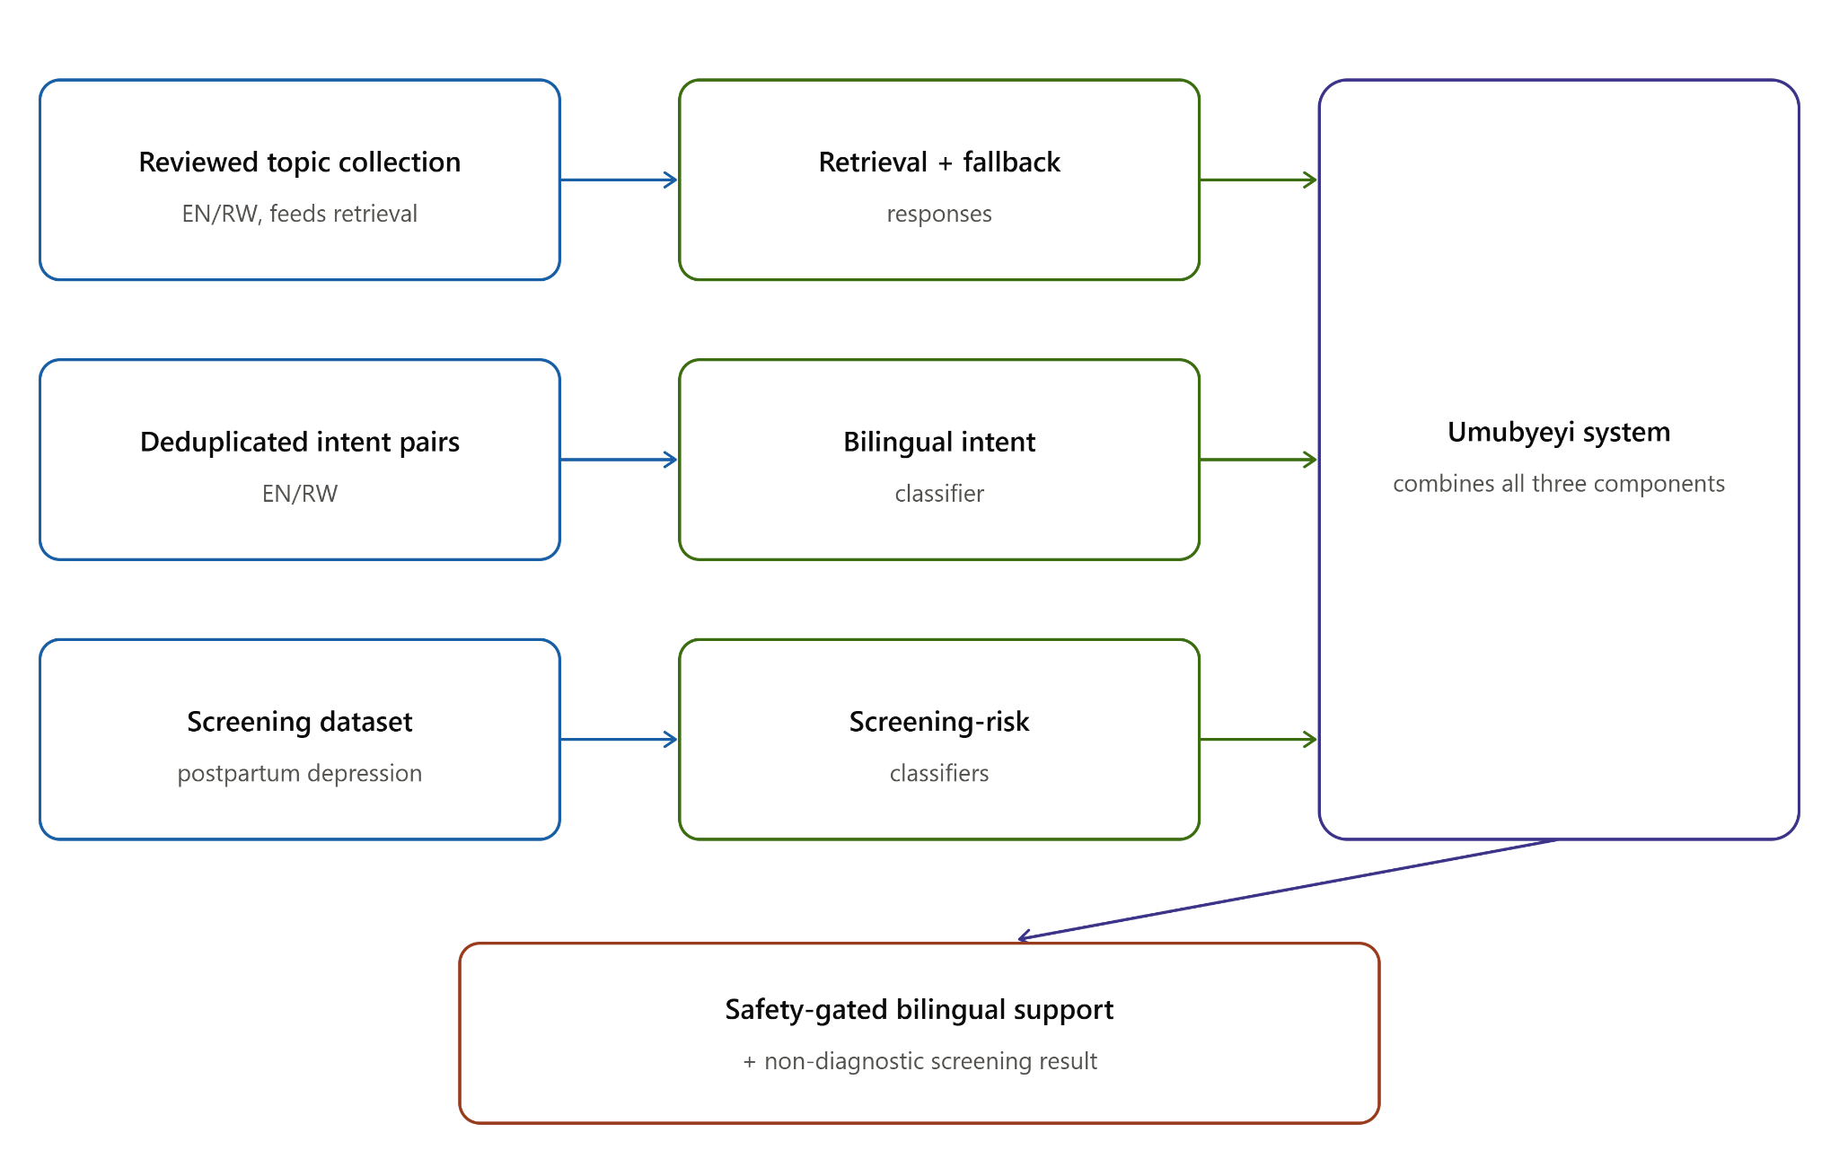
Shows how the three real data sources used in this project -- the reviewed topic collection, the deduplicated intent pairs, and the postpartum screening dataset -- each feed the model they trained, converging into the overall Umubyeyi system.

3.3 Development Methodology
The project followed the Spiral Development Life Cycle (Boehm, 1988). This model was chosen over a purely linear approach because Umubyeyi combines several independent components: a safety and scope router, language and intent classifiers, a retrieval layer, a generation cascade, and screening-risk classifiers, each of which carried its own risks and needed to be evaluated and refined before the next layer could be built on top of it with any confidence.
Each cycle followed the same four steps: define what the layer needed to do, identify the main risk (for example, false-negative crisis detection for the safety gate, or target leakage for the screening classifiers), build and test a version against held-out data or controlled cases, then plan the next cycle based on what the results showed. The safety and scope rules were built and tightened first, since every later component depends on messages being routed correctly. The classification, retrieval, and generation layers were then developed and evaluated in their own cycles, and finally integrated and tested end to end.
This iteration was technical rather than participatory: each spiral cycle was driven by held-out data, automated tests, and the author's own review, not by feedback from mothers or health workers, since no user testing took place in this phase (see Section 1.7). A future iteration of this project would benefit from including that feedback directly in the spiral, particularly for the safety and scope rules.

3.4 Functional and Non-Functional Requirements

Functional Requirements
The system was required to:

• Accept English and Kinyarwanda messages and detect the input language.
• Provide Groq-based wellbeing conversation with reviewed fallback content.
• Run language, emotional-intent, and screening-risk predictions using project-trained models.
• Route crisis, clinical, baby-care, and unrelated messages before normal conversation.
• Provide an EPDS-10-based wellness test and a guided non-diagnostic check-in.
• Show the user's wellness, mood, and check-in history in a progress dashboard.
• Store chat and progress information in the browser rather than storing message content on the server.
• Remain usable on a mobile browser without an application download.

Non-Functional Requirements
• Safety and scope rules must run before a conversational response is requested.
• A failed API or rejected response must return reviewed fallback content rather than an empty result.
• Raw messages and check-in answers must not be stored in optional server analytics.
• The mother may optionally set a local PIN to lock the whole app or individual chats; no account or server-side recovery exists.
• Heavy experimental components may run locally when they exceed the deployed serverless limits.

3.5 System Architecture
Umubyeyi uses a hybrid architecture. Deterministic safety rules run first. Project-trained models handle language, intent, and screening tasks. Groq provides the main English and Kinyarwanda conversations, while the reviewed passage serves as the final fallback. The fine-tuned BLOOMZ model remains a locally evaluated experiment and is not part of the Vercel deployment.

Figure 2: Technical system architecture
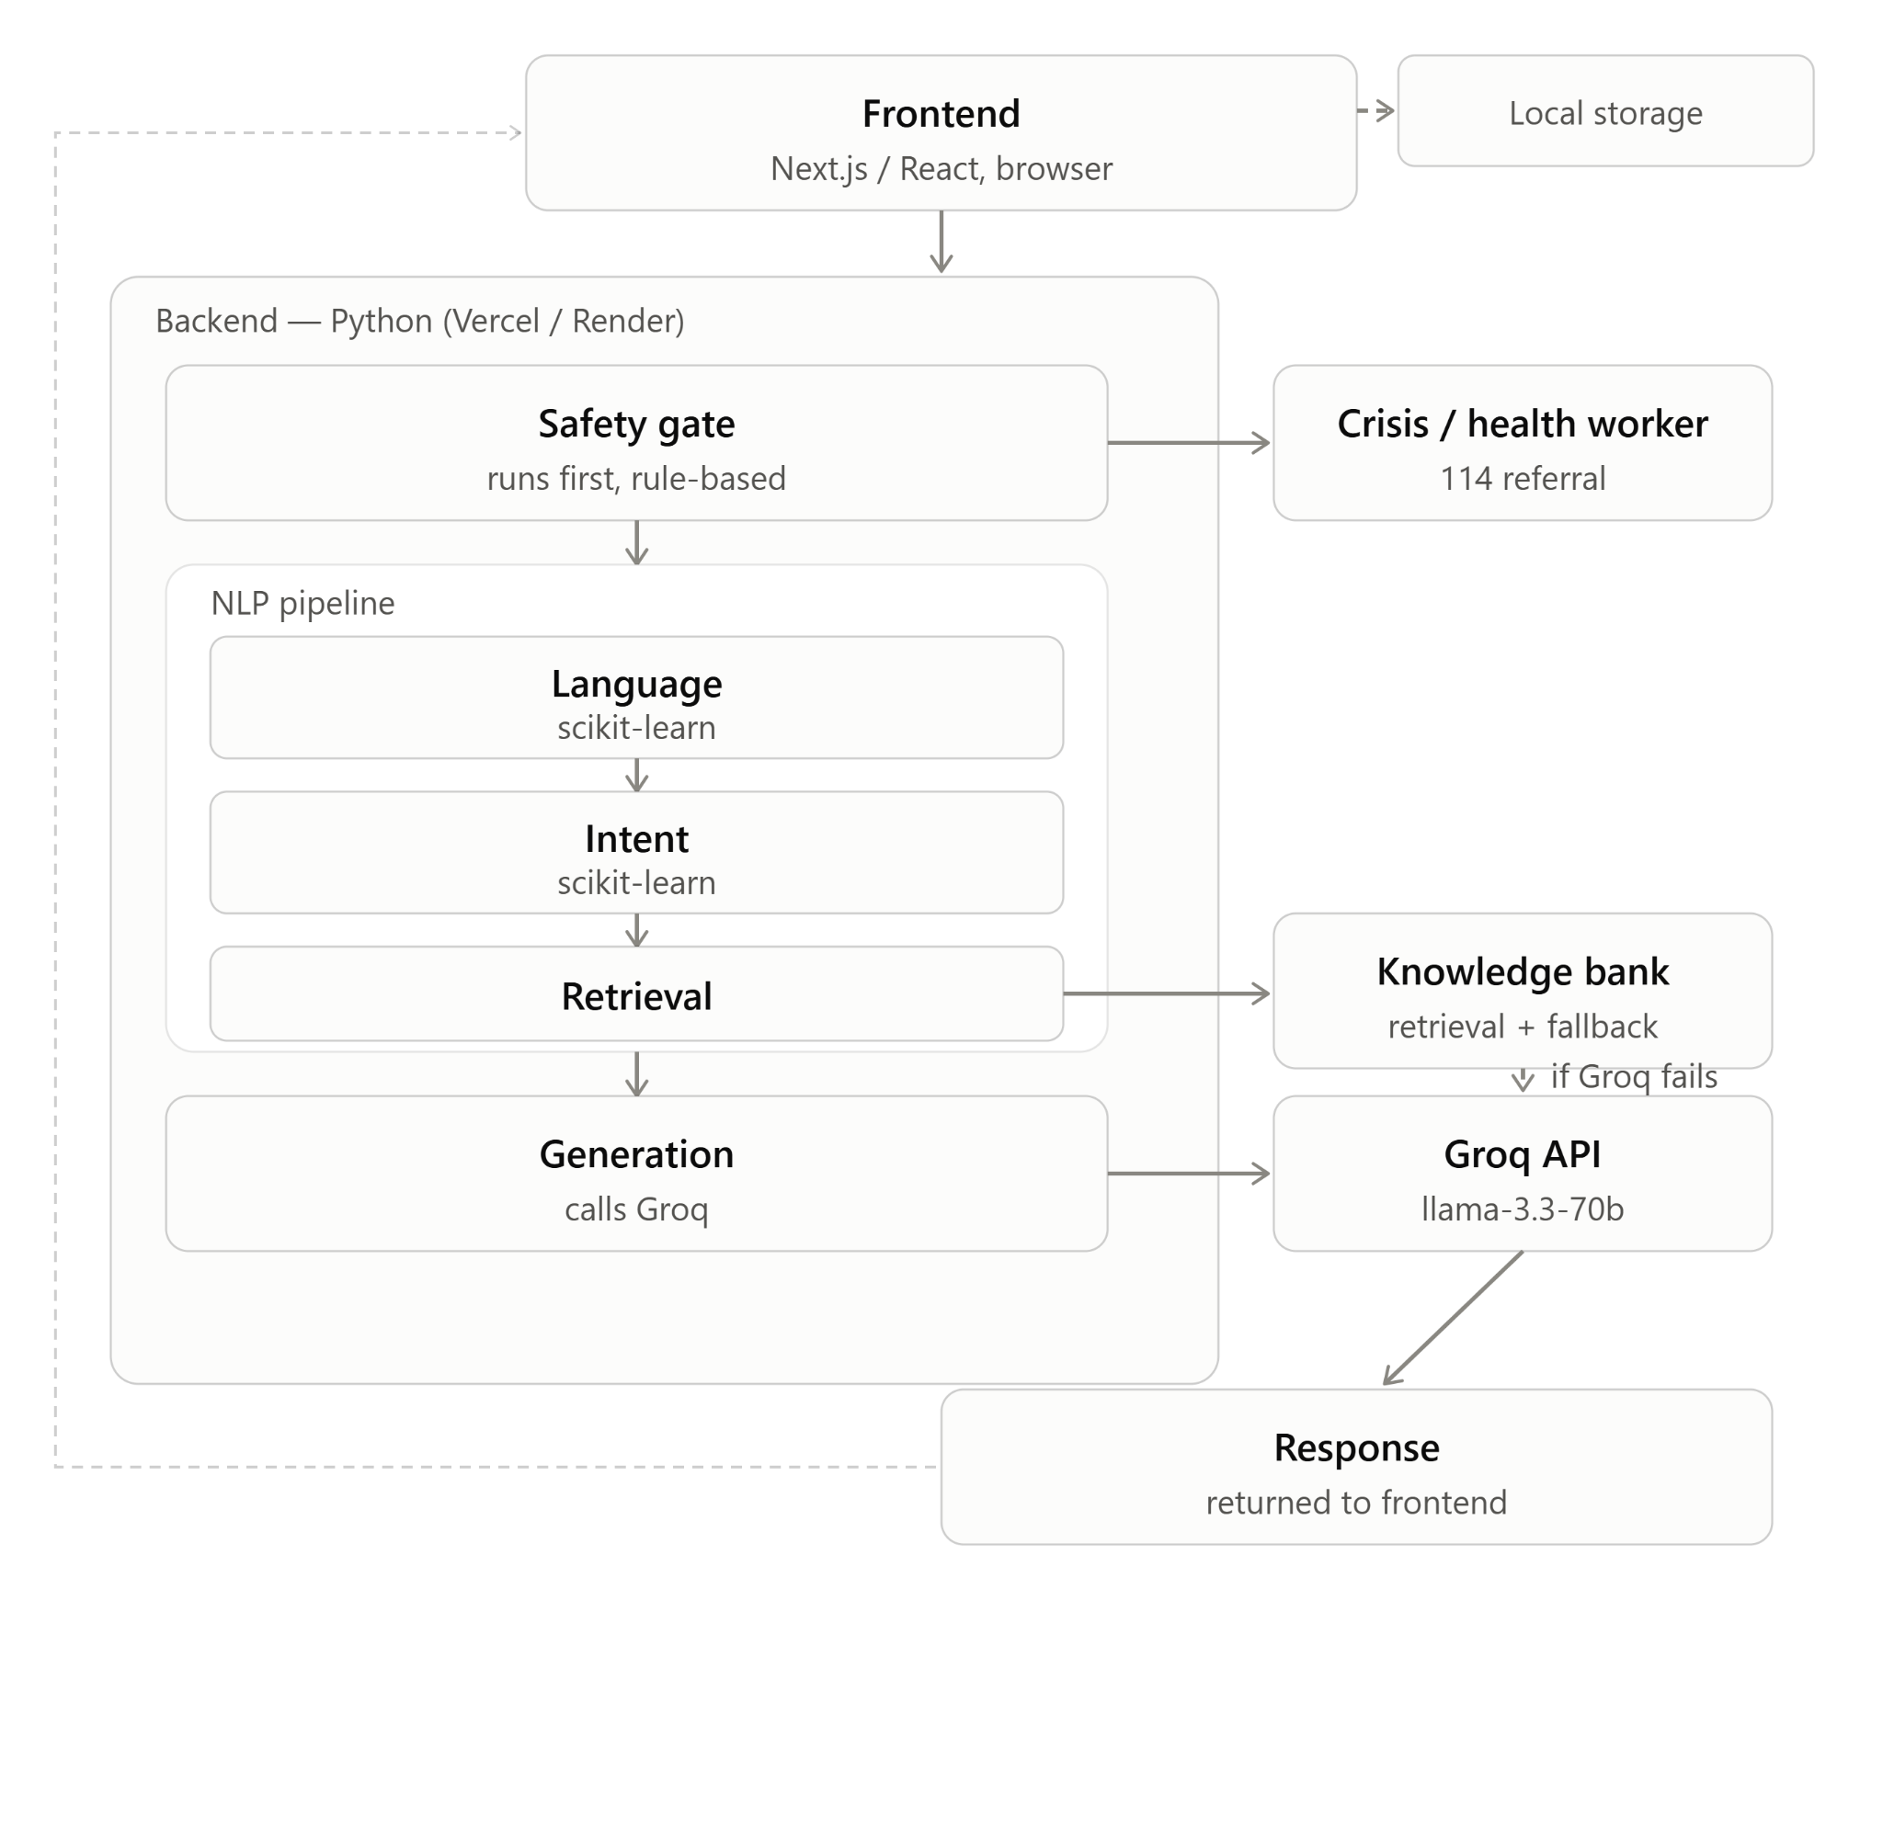

Traces a request from the Next.js frontend through the safety gate, language and intent detection, retrieval, and the Groq-primary generation cascade, alongside the separate guided check-in and screening path.

The frontend is built with Next.js and React. Python endpoints provide chat, screening, feedback, and title functions. Chat and progress information are stored in the browser, while optional server analytics exclude message content.

Component | File / Location | Role
Frontend | app/, components/, lib/ (Next.js/React) | Chat interface, EPDS-10 flow, guided check-in, progress dashboard, self-care
Core pipeline | src/rag.py | Orchestrates the safety gate, language detector, retrieval, and the generation cascade
Language detector | models/lang_detector.joblib | Detects English or Kinyarwanda
Bilingual intent classifier | models/topic_classifier.joblib | Predicts emotional intent; maps to the 14 reviewed knowledge-bank topics
Knowledge bank | data/knowledge/postpartum_wellbeing.json | 14 reviewed, source-attributed bilingual postpartum topics
Primary generator | src/groq_generator.py (Groq API) | Hosted large language model; primary wellbeing-answer, greeting, and title generator
Fallback generator | models/umubyeyi-bloomz-lora/, src/finetuned_generator.py | Project fine-tuned BLOOMZ-560m; English-only local experiment, not deployed on Vercel
Screening-risk classifiers | models/ (full + check-in pipelines) | Elevated-risk estimate from licensed postpartum depression data; not diagnosis
Explainability | src/explain.py | Real-time, model-agnostic SHAP explanation of the check-in result
EPDS-10 assessment | lib/epds.ts, components/EpdsAssessment.tsx | EPDS-10-based wellness self-assessment with crisis interception; not diagnosis
Progress dashboard | components/ProgressDashboard.tsx | Client-side trend view of EPDS, mood, and check-in history
Analytics (optional) | src/db.py | Anonymous, non-content session analytics; Postgres or local SQLite

3.6 UML Diagrams
The diagrams show the main users, components, and request flow. They cover chat, wellness testing, guided check-in, progress tracking, safety routing, and the response fallback sequence.

Figure 3: Request lifecycle flowchart

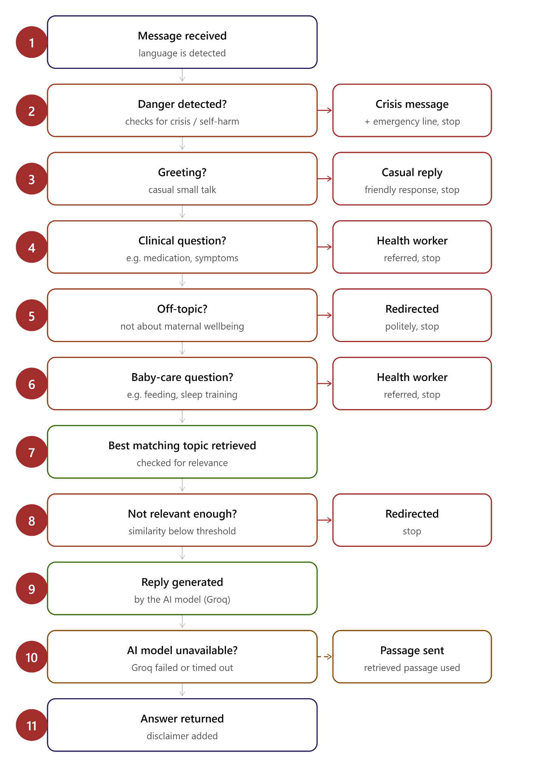
Shows the exact order safety checks run in before any reply is generated: danger, greeting, clinical, off-topic, and baby-care messages are all intercepted before the system ever reaches the generation step.

Figure 4: Use case diagram

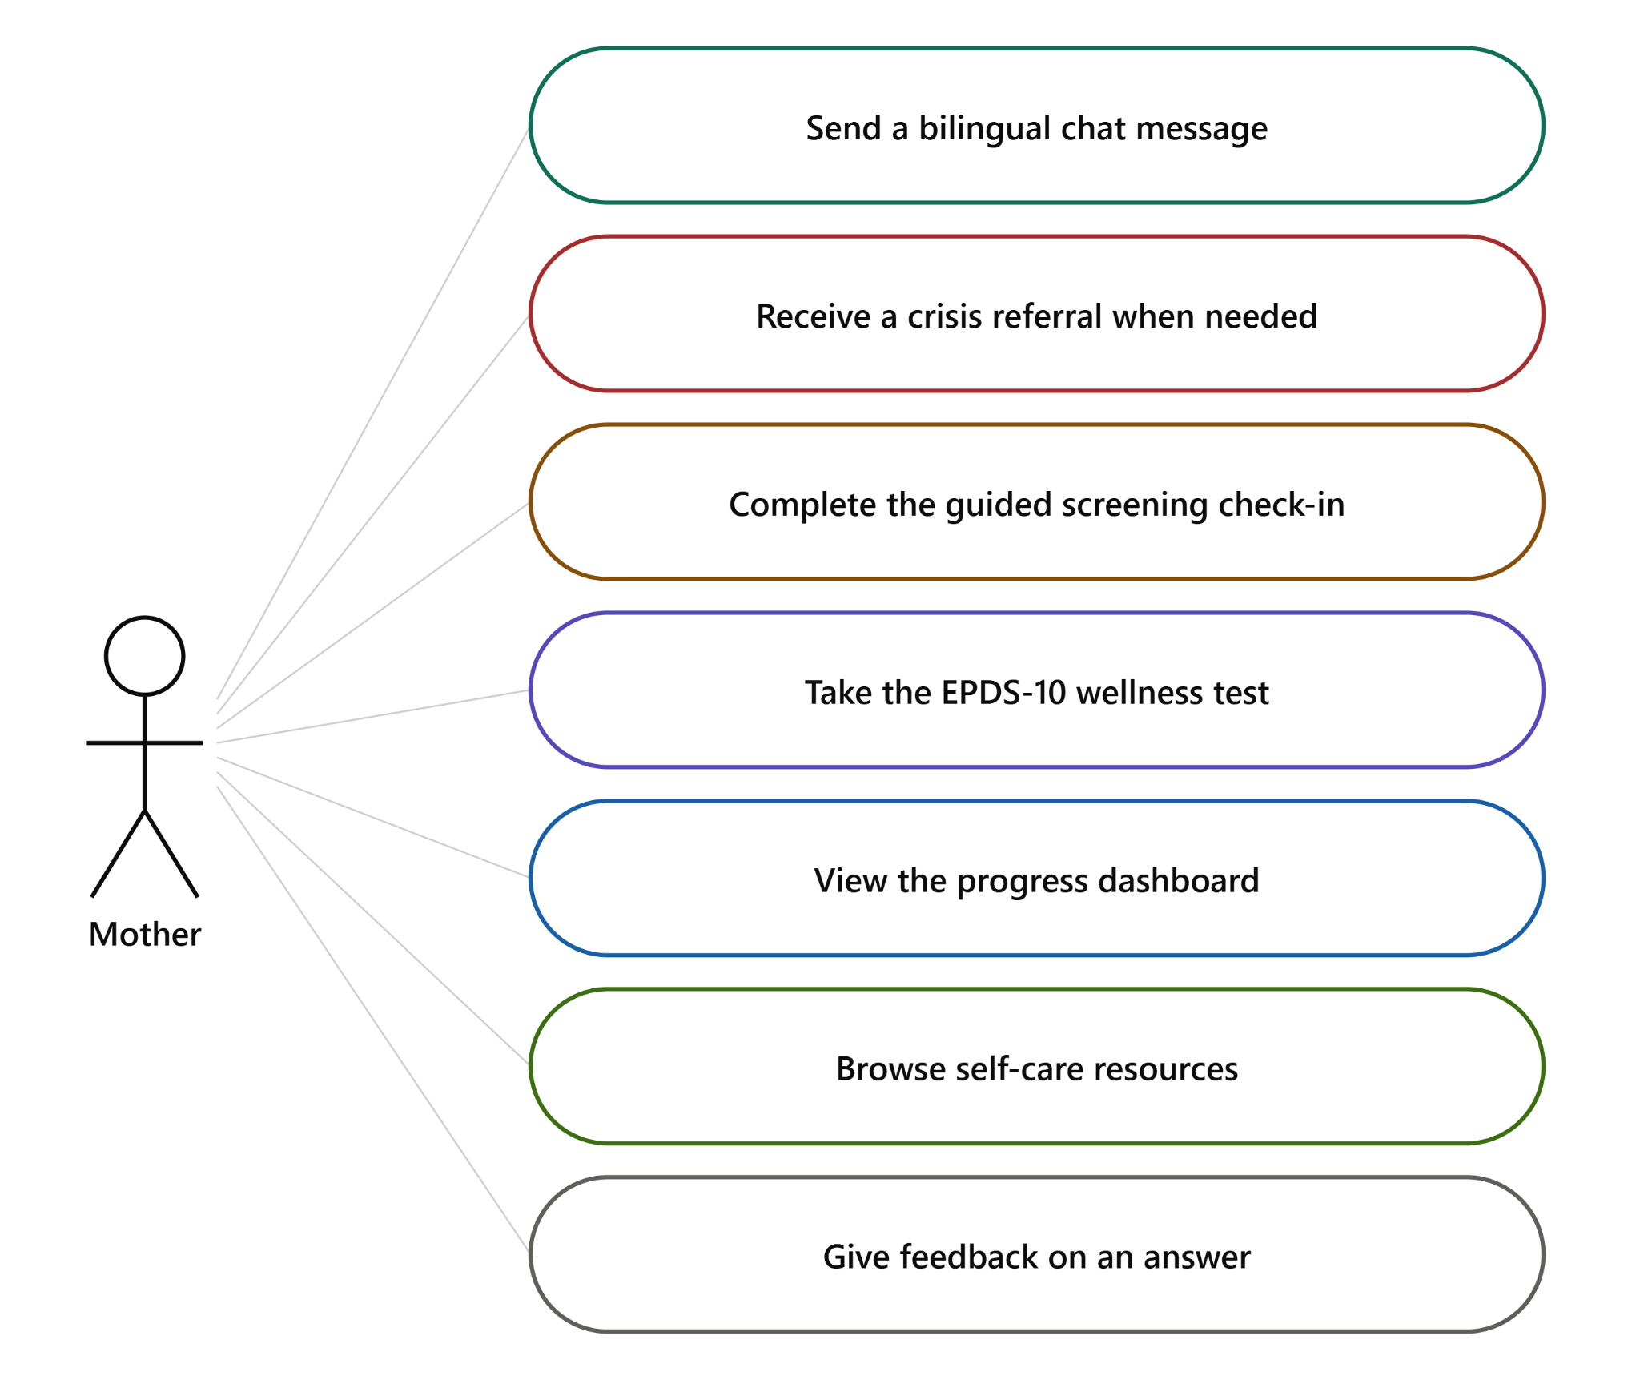
Lists what a mother can do with the deployed system: send a message, receive a crisis referral, complete the guided check-in, take the EPDS-10 test, view her progress, browse self-care resources, and give feedback.

Figure 5: Class diagram
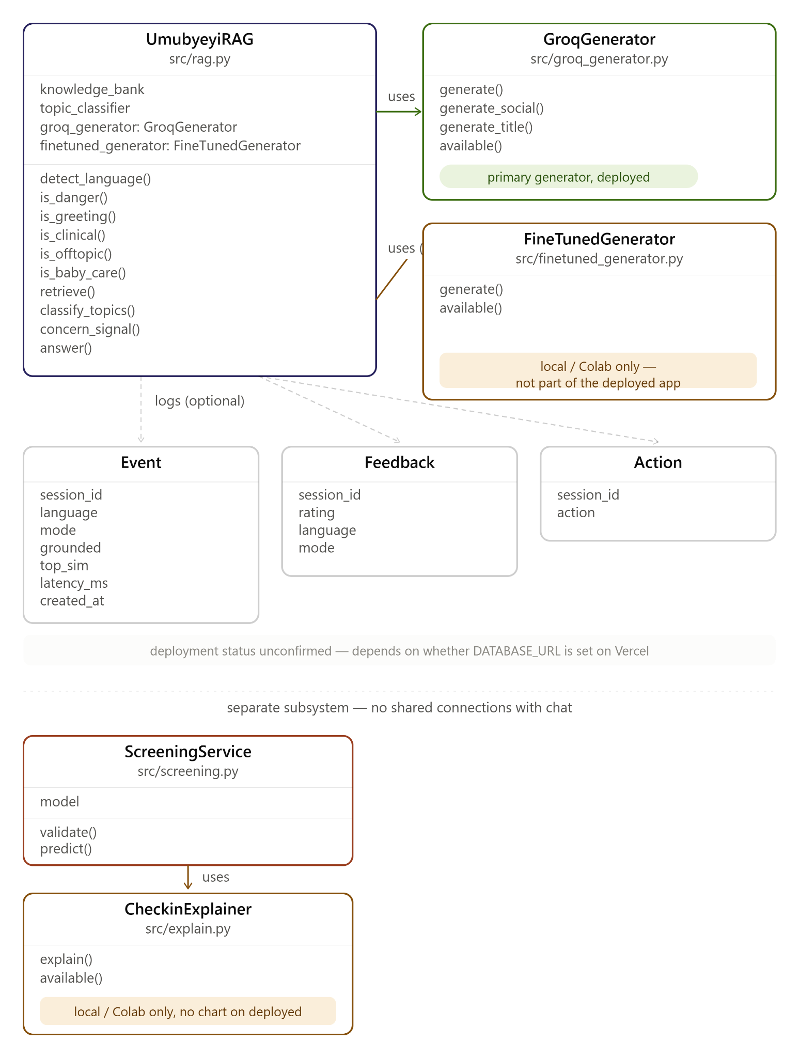
Shows how the main backend classes hand off responsibility: the orchestrator runs the safety checks, calls the generator for a reply, and falls back to the retrieved passage if that fails, while the screening service is a separate, unconnected path.

Figure 6: Sequence diagram

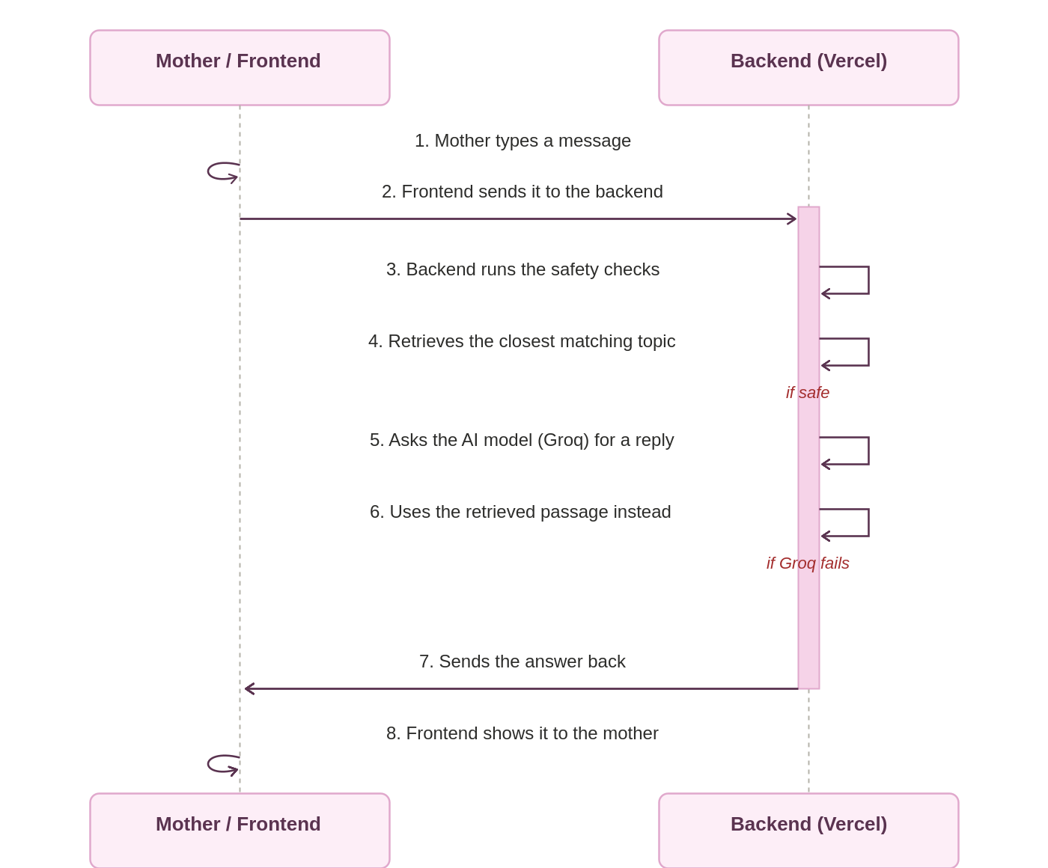
Traces one chat request end to end, from the mother's message through the safety checks and generation cascade to the reply she sees, including the fallback path if the primary generator fails.

3.7 Development Tools
Table 6 lists the tools and libraries used in implementation:

Tool / Library | Role
Python 3.11-3.13 | Backend pipeline, classifiers, generator fine-tuning and inference
scikit-learn 1.9 | Language detector, bilingual intent classifier, and both screening-risk classifiers
Hugging Face Transformers, PEFT, and Datasets | BLOOMZ-560m LoRA training and local evaluation
bigscience/bloomz-560m | Pre-trained decoder-only base model used in the local fine-tuning experiment
Groq API (llama-3.3-70b-versatile) | Primary wellbeing-answer, greeting, and title generator
SHAP | Real-time, model-agnostic explanation of the check-in risk classifier (local/Colab only)
TF-IDF (scikit-learn) | Character n-gram retrieval engine over the knowledge bank
Next.js 15 / React 19 / TypeScript | Web frontend, deployed on Vercel
Recharts | Progress-dashboard trend charts
Vercel (Python serverless functions) | Deployment for both the frontend and the backend API
Google Colab (T4 GPU) | Cloud GPU environment for BLOOMZ fine-tuning
pytest | Automated unit, integration, and HTTP-contract testing (87 tests at final review)
pandas / NumPy | Data processing and evaluation analysis
PostgreSQL (Neon) / SQLite | Optional anonymous analytics storage
JSON | Knowledge bank storage format
GitHub / Vercel CI | Version control and deployment pipeline

CHAPTER 4: SYSTEM IMPLEMENTATION AND TESTING

4.1 Implementation and Coding

4.1.1 Introduction
The system was implemented as separate components and then integrated into one pipeline. This made it possible to test language detection, retrieval, generation, screening, and safety behaviour independently before end-to-end testing.

4.1.2 Description of Implementation Tools and Technology
The language detector uses character-level TF-IDF features and a scikit-learn classifier. The bilingual intent model combines word and character TF-IDF features; seven candidate algorithms were compared and Extra Trees was selected.
The retriever compares each message with the 14 English or Kinyarwanda reference topics using cosine similarity. Its best matches support topic selection and provide the final response when generation is unavailable.
Groq is the primary conversational generator. The project also fine-tuned BLOOMZ-560m with LoRA on English ESConv supportive-conversation data. The model improved over its base checkpoint in English, but it did not provide reliable Kinyarwanda responses. Groq was therefore selected to support conversation in both project languages.
The screening service loads the trained check-in model and returns a non-diagnostic risk category. SHAP can explain the result locally. The EPDS-10-based wellness test is scored separately and does not use the prediction model.
Safety rules run before generation. Crisis messages receive an urgent referral, clinical and baby-care messages are directed to a health worker, and unrelated messages receive a scope reminder.

4.2 Graphical View of the Project

4.2.1 Screenshots with Description
The screenshots show the implemented chat, wellness test, guided check-in, progress tracking, and safety responses. They demonstrate the interface and completed features, not clinical effectiveness.

Screenshot 1:Home page
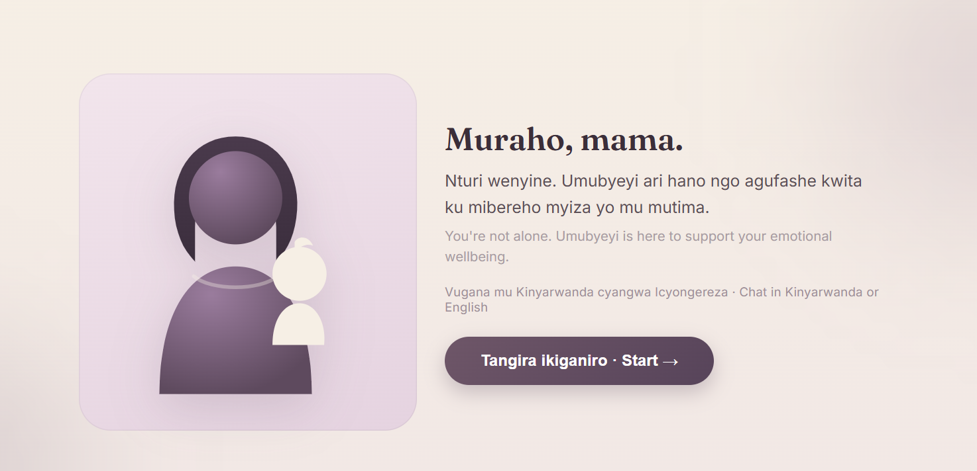

Screenshot 2: English emotional support response Description:
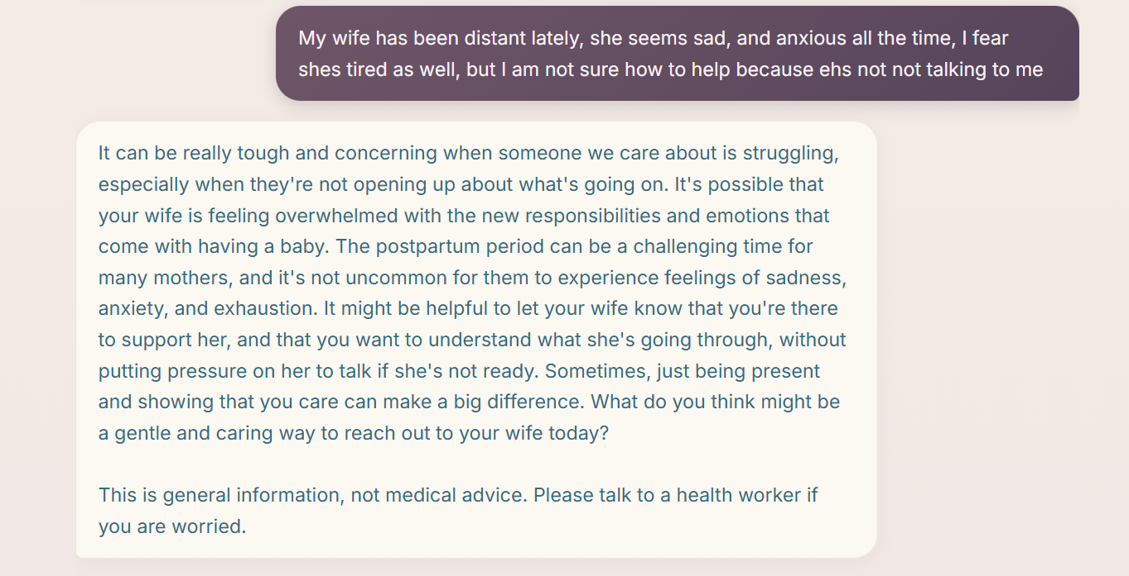

Screenshot 3: Kinyarwanda emotional support response Description:
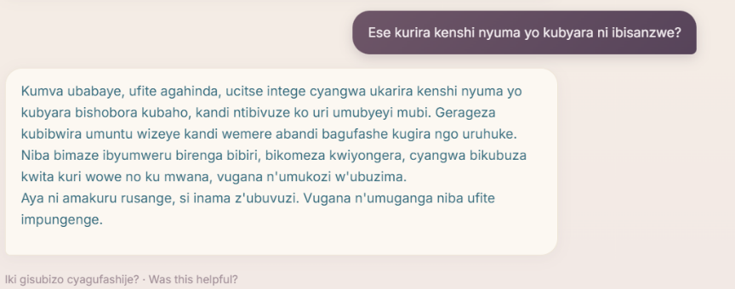

Screenshot 4: Clinical referral response Description


Screenshot 5: Crisis referral response Description:
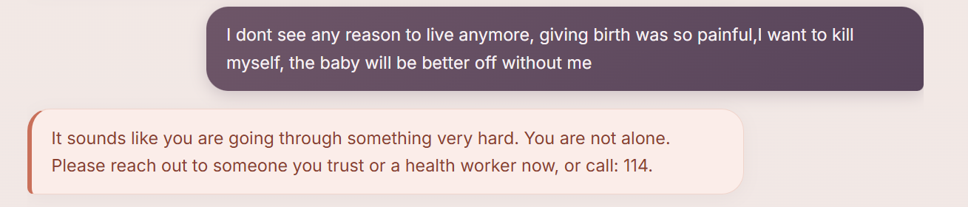

Screenshot 6: Breathe or Help modal Description:

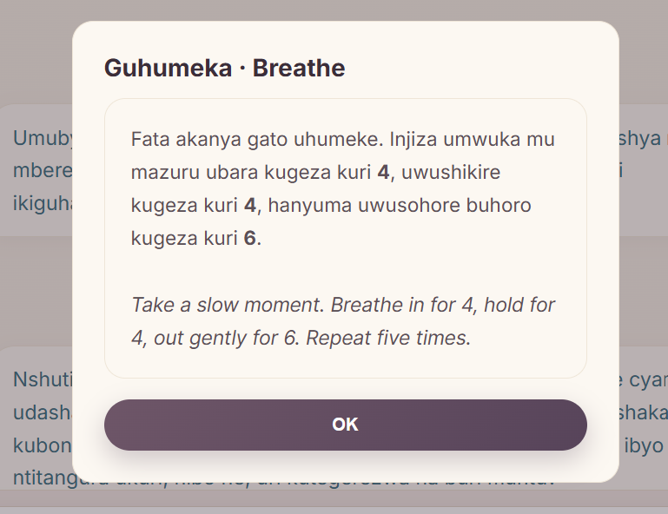
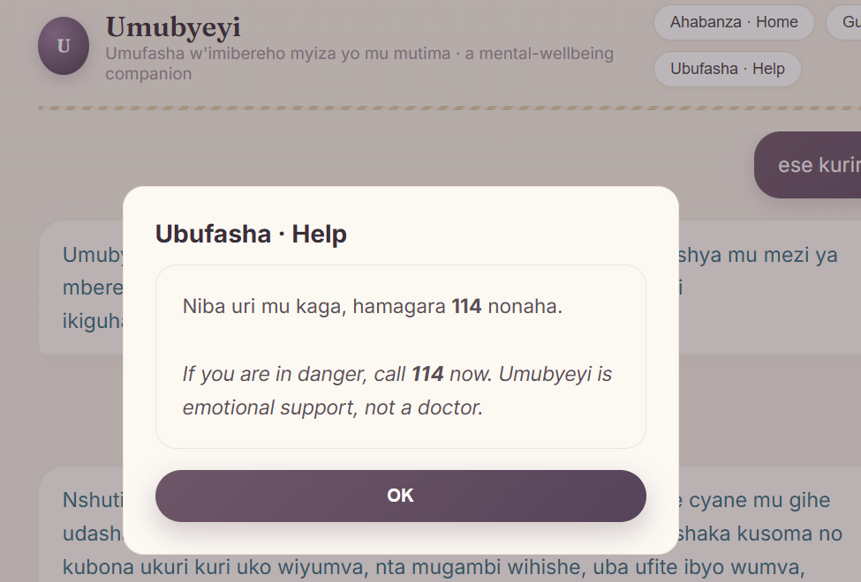

4.3 Testing

4.3.1 Introduction
Testing covered individual components, integration, user-facing functions, and acceptance against the six objectives. At final review, all 87 automated tests passed.

4.3.2 Objective of Testing
Testing checked whether the system followed its defined routing and fallback rules. Special attention was given to preventing the controlled crisis and clinical cases from reaching a conversational generator. These tests do not prove that every real-world phrasing will be detected.

4.3.3 Unit Testing
Unit tests covered each pipeline component in isolation. Table 7 summarises the unit tests and their outcomes:

Unit Test | Expected Outcome / Result
Safety gate crisis input ("I want to harm myself") | Returns Rwanda 114 referral before any model is consulted: PASS
Safety gate clinical input ("My baby has a fever") | Returns health worker referral; no medical content: PASS
Safety gate off-topic input ("Can you help with football?") | Returns scope redirect: PASS
Safety gate emotional input ("I feel so sad") | Passes through to language detection and generation: PASS
Language detector English and Kinyarwanda input | Detects the correct language for both test cases: PASS
Groq used first for in-scope English messages | Response mode is groq_general; answer is grounded-in-safety, not evidence-constrained: PASS
Fine-tuned generator exercised locally when Groq is disabled | Local pipeline selects the fine-tuned path when enabled: PASS; Vercel uses retrieval fallback
Kinyarwanda skips the fine-tuned generator | RW messages fall to Groq or retrieval, never the English-only fine-tuned model: PASS
Conversation history threaded into the active generator | A bare follow-up ("okay how should I handle this") stays in scope: PASS
Groq request survives a Cloudflare/User-Agent block | An explicit User-Agent header is set on every Groq request: PASS
Generated-output safety validation | Overly short answers and unverifiable invented numbers are rejected: PASS
EPDS-10 item-10 self-harm answer | Routes directly into the existing crisis modal, no separate safety logic: PASS
SHAP explanation shape and fallback | Returns ranked, signed feature contributions, or None on any failure, never a 500: PASS
Response object format | All responses include answer, language, mode, grounded, and sources fields: PASS

4.3.4 Validation Testing
Validation used 14 controlled retrieval paraphrases per language and 16 controlled safety and scope cases. The expected topic or route was compared with the system output. Results are presented in Chapter Five.

4.3.5 Integration Testing
Integration tests checked the order of the pipeline: safety before generation, language selection, Groq conversation, fallback behaviour, conversation history, screening, and API responses. All defined integration tests passed.

4.3.6 Functional and System Testing
Functional testing confirmed that the implemented interface could process both languages, run the wellness and check-in features, track progress locally, and return the defined safety responses. English retrieval achieved Top-1 accuracy of 0.6429 and Top-3 recall of 0.9286 on its controlled test. The Kinyarwanda retrieval cases require native-speaker evaluation before broader claims can be made.

4.3.7 Acceptance Testing Report
Acceptance testing assessed the prototype against the six objectives in Section 1.4. The bilingual interface, trained classifiers, hybrid conversation, wellness and check-in features, deterministic routing, deployment, and layer-specific evaluation were implemented. The controlled tests confirm the specified prototype behaviour but do not establish clinical validity.

CHAPTER 5: THE DESCRIPTION OF THE RESULTS/SYSTEM

5.1 Intent Classification Results
Seven intent-classification algorithms were compared on the same train and validation split. Extra Trees was selected and then evaluated on the untouched test set. English macro-F1 was 0.7180, while Kinyarwanda macro-F1 was 0.2762. The difference shows the limitation of machine-translated, weakly labelled Kinyarwanda training data.

Model | Accuracy | Top-3 Accuracy | Macro-F1 | Key Finding
Dummy baseline | 0.326 | 0.528 | 0.082 | Majority-class floor
Complement NB | 0.478 | 0.848 | 0.395 | Simple baseline; missed minority classes
Logistic Regression | 0.506 | 0.843 | 0.480 | Fast, interpretable, close behind SVM
Calibrated Linear SVM | 0.506 | 0.826 | 0.474 | Strong on this split, slightly behind Logistic Regression on macro-F1
Random Forest | 0.551 | 0.888 | 0.518 | Solid ensemble result
Extra Trees - selected | 0.601 | 0.893 | 0.555 | Best validation macro-F1; deployed
K-Nearest Neighbors | 0.399 | 0.753 | 0.387 | Weakest of the trained candidates

Figure 7: Confusion matrix(intent classification)

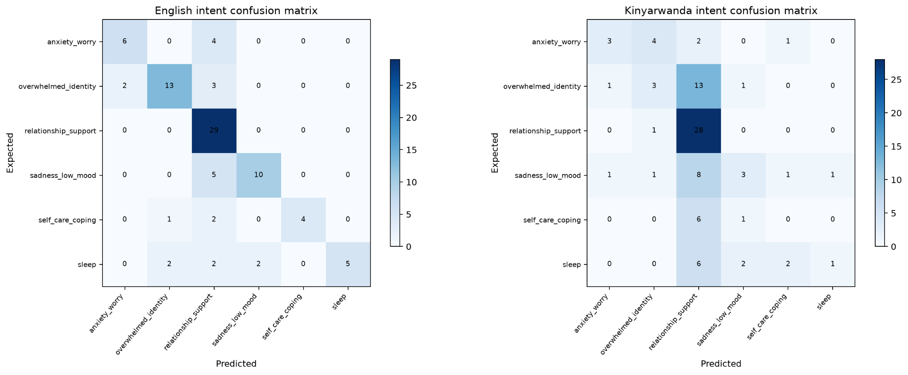

Compares predicted against actual intent for the deployed Extra Trees model on the untouched test set, shown separately for English and Kinyarwanda so the gap between the two languages is visible directly rather than hidden inside a single accuracy number.
Figure 8: Validation-set confusion matrix per candidate, bilingual intent classifier
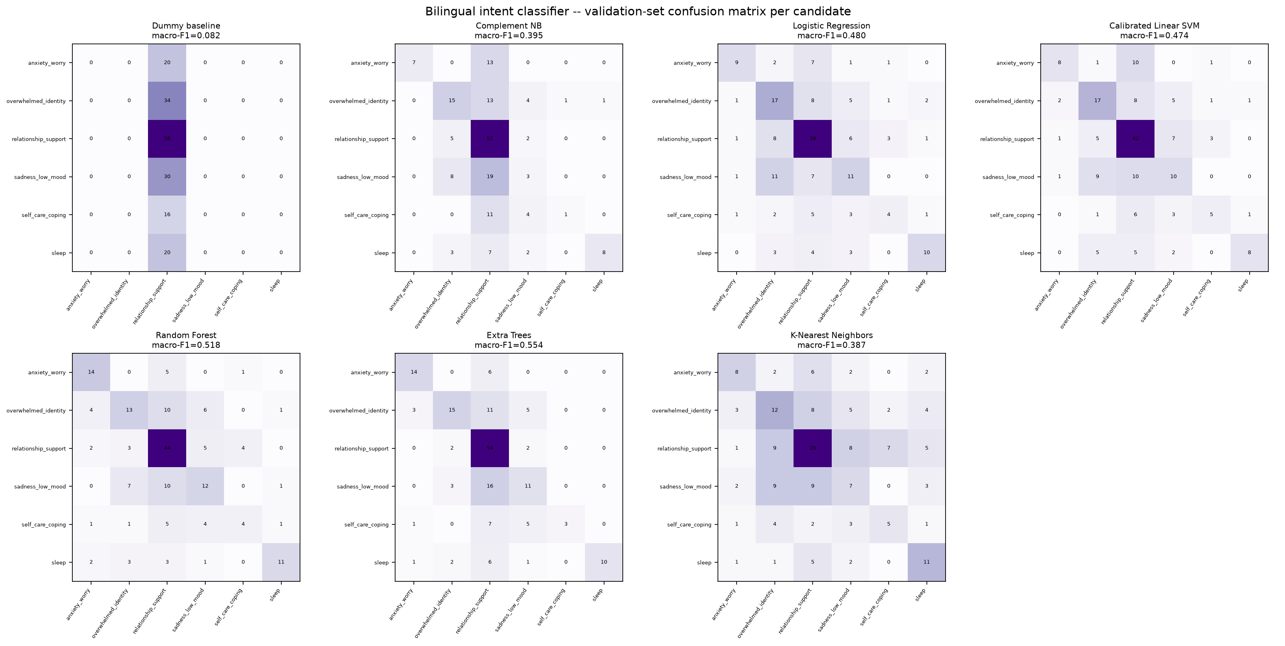
Shows the same validation-set confusion matrix for all seven candidate algorithms side by side, not only the winner, making visible which specific intents each candidate confused before Extra Trees was selected.

Figure 9: Model comparison bar chart, accuracy, macro-F1, and top-3 accuracy for all seven candidates
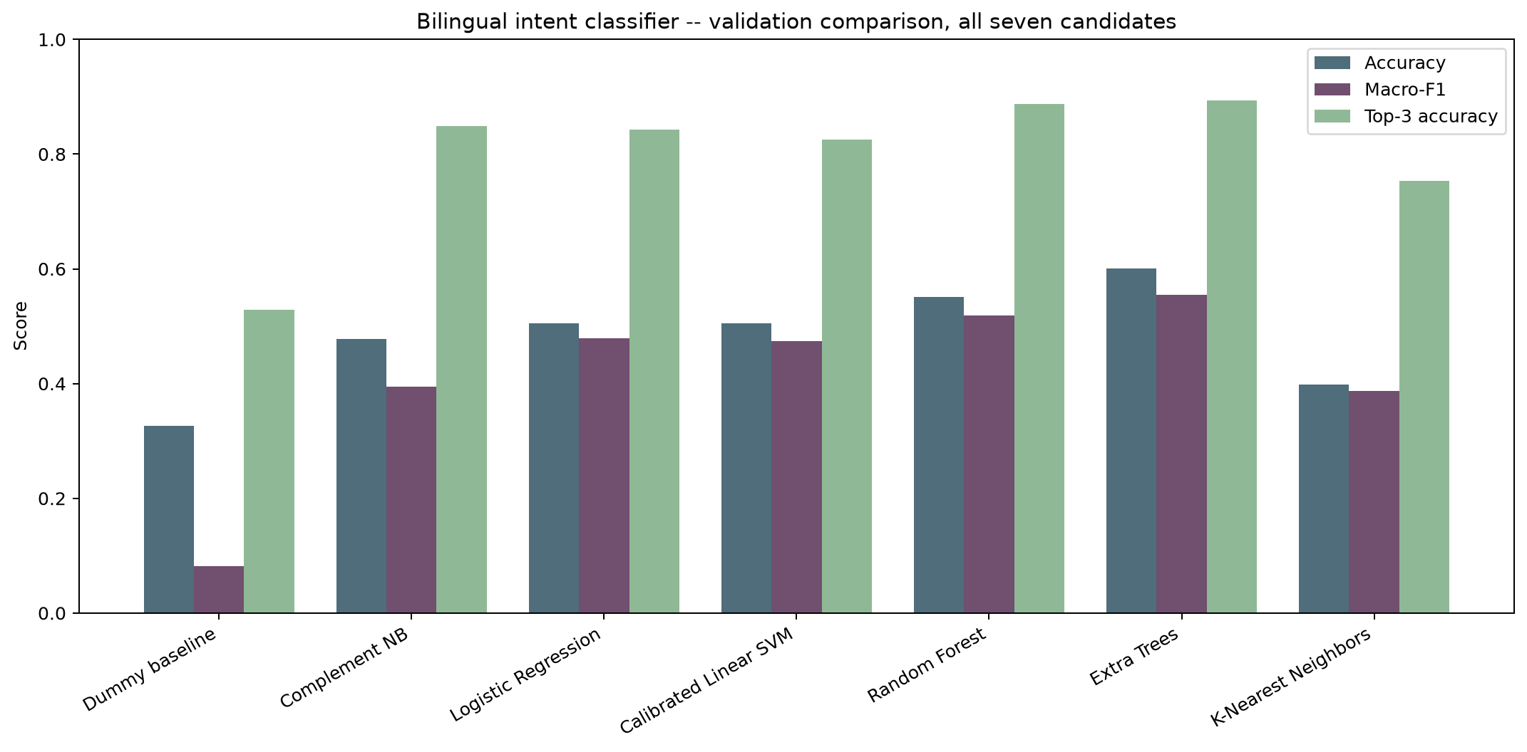
Compares accuracy, macro-F1, and top-3 accuracy across all seven candidates on the same validation split, showing Extra Trees ahead on every metric shown, not only the one used to select it.

5.1.1 Bilingual Retrieval Results
Retrieval was tested using 14 controlled paraphrases per language. English achieved Top-1 accuracy of 0.6429 and Top-3 recall of 0.9286. The project-authored Kinyarwanda cases scored higher, but this result is limited because they share vocabulary with the reference collection and were not independently reviewed by native speakers.

Test Condition | Results
English retrieval (14 controlled paraphrases) | Top-1: 0.6429 | Top-3: 0.9286
Kinyarwanda retrieval (14 controlled, project-authored cases) | Top-1: 1.0000* | Top-3: 1.0000*
Interpretation | *Kinyarwanda cases share vocabulary with the knowledge bank; reported as controlled software evidence pending native-speaker review, not general-performance proof.

5.1.2 Screening-Risk Classifier Results
Seven algorithms were compared for a full 46-predictor screening model and a reduced 15-input guided check-in model. Random Forest was selected for the full model and Logistic Regression for the check-in model using validation F1.
Table 10: Full 46-predictor screening model comparison, all seven candidates (validation set)
Model | Accuracy | Precision | Recall | F1
Dummy baseline | 0.5667 | 0.0000 | 0.0000 | 0.0000
Logistic Regression | 0.6750 | 0.6066 | 0.7115 | 0.6549
Decision Tree | 0.6333 | 0.5952 | 0.4808 | 0.5319
Random Forest - selected | 0.7583 | 0.7091 | 0.7500 | 0.7290
Extra Trees | 0.7417 | 0.6780 | 0.7692 | 0.7207
Support Vector Machine | 0.7417 | 0.6721 | 0.7885 | 0.7257
K-Nearest Neighbors | 0.7583 | 0.8710 | 0.5192 | 0.6506
Table 11: Guided check-in model comparison, all seven candidates (validation set)
Model | Accuracy | Precision | Recall | F1
Dummy baseline | 0.5667 | 0.0000 | 0.0000 | 0.0000
Logistic Regression - selected | 0.7417 | 0.6780 | 0.7692 | 0.7207
Decision Tree | 0.7250 | 0.6792 | 0.6923 | 0.6857
Random Forest | 0.7250 | 0.6727 | 0.7115 | 0.6916
Extra Trees | 0.7000 | 0.6379 | 0.7115 | 0.6727
Support Vector Machine | 0.7250 | 0.6667 | 0.7308 | 0.6972
K-Nearest Neighbors | 0.7000 | 0.6667 | 0.6154 | 0.6400
On the untouched test set, the full model achieved F1 = 0.7890 and the check-in model achieved F1 = 0.7544. These are dataset results, not clinical performance estimates for Rwanda. SHAP explanations are available locally for the check-in result.
Experiment | Selected Model | Accuracy | Precision | Recall | F1
Full 46-predictor research model | Random Forest | 0.8083 | 0.7679 | 0.8113 | 0.7890
Reduced 15-input guided check-in | Logistic Regression | 0.7667 | 0.7049 | 0.8113 | 0.7544
Table 12: Screening-risk classifier results, untouched test set

Figure 10: Full 46-predictor screening model, validation comparison, all seven candidates
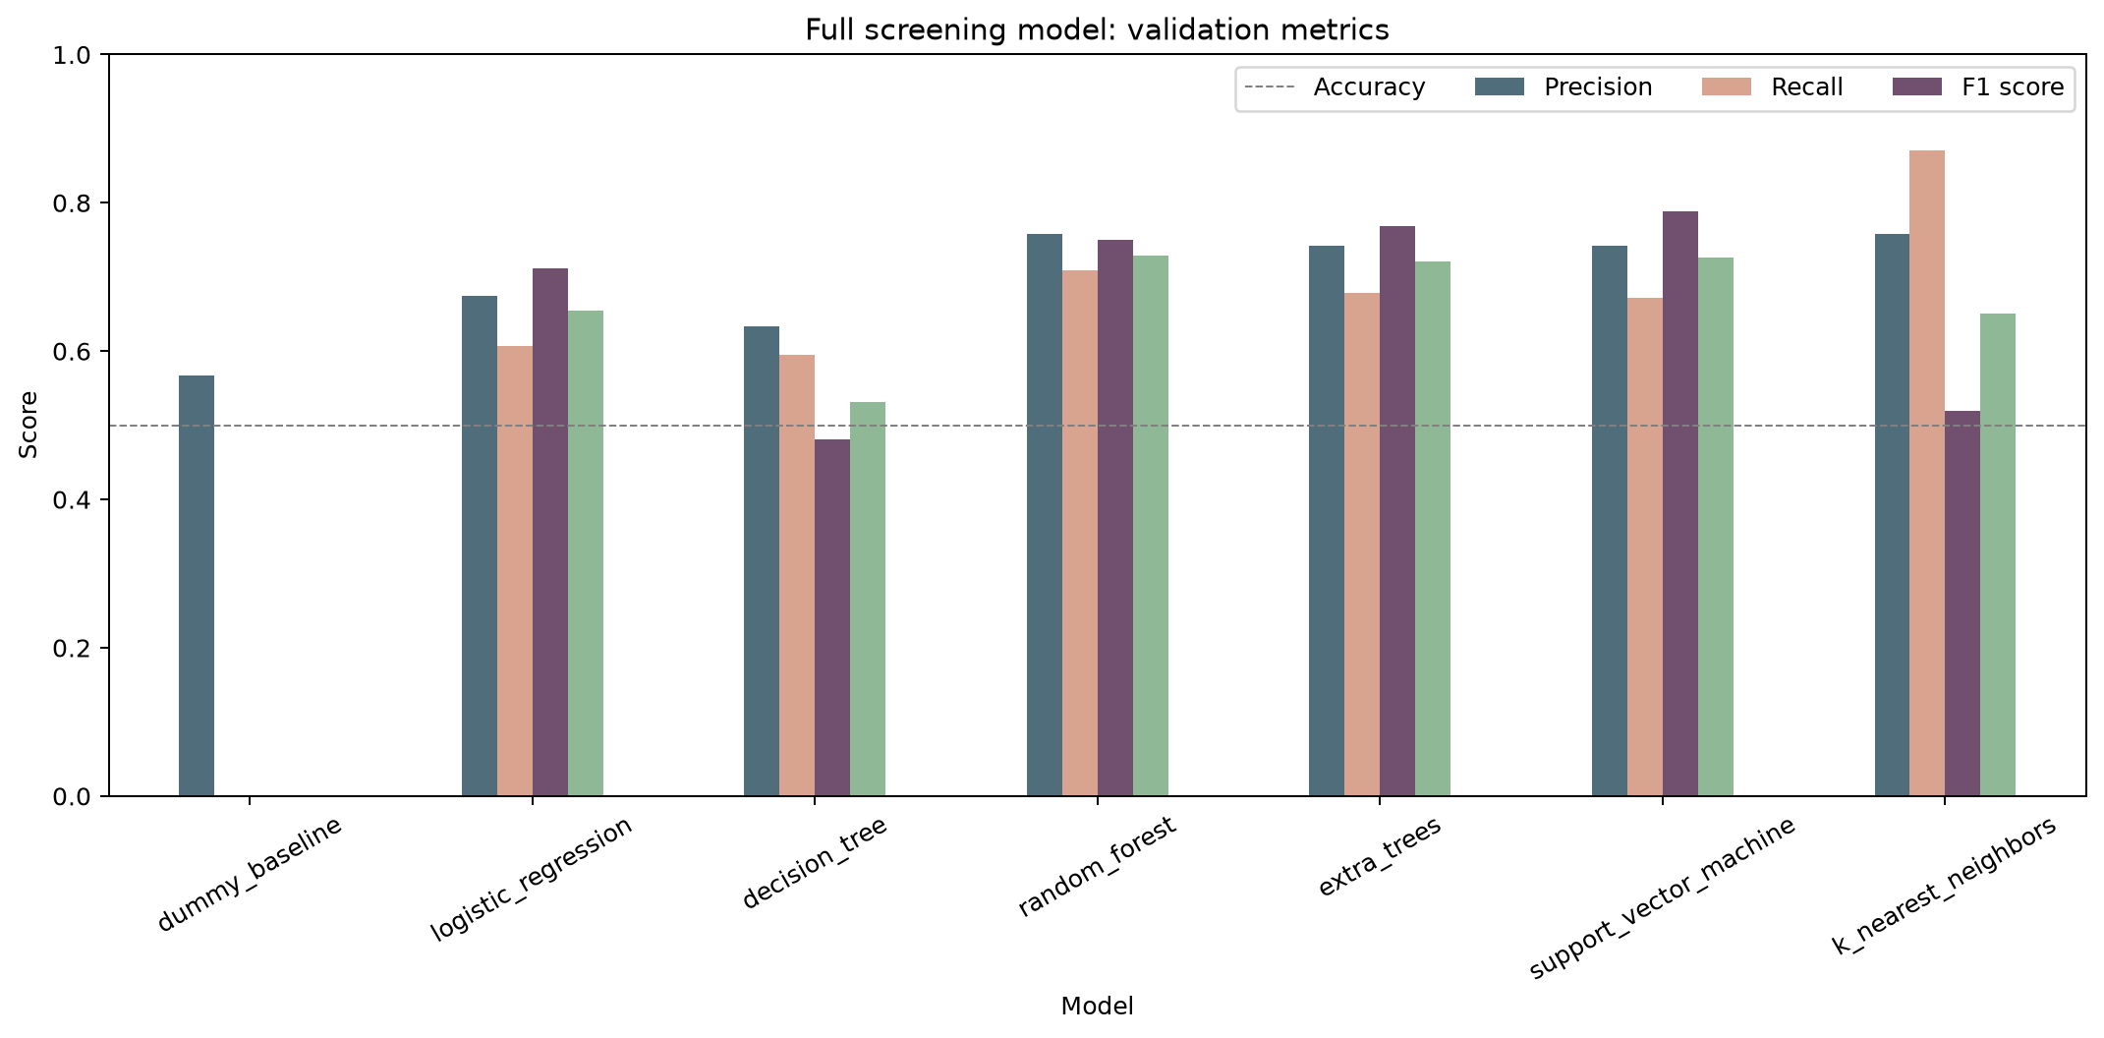
Compares the same three metrics across all seven candidate algorithms for the full screening model, showing why Random Forest was selected over the other six.
Figure 11: Full 46-predictor screening model, validation-set confusion matrix per candidate
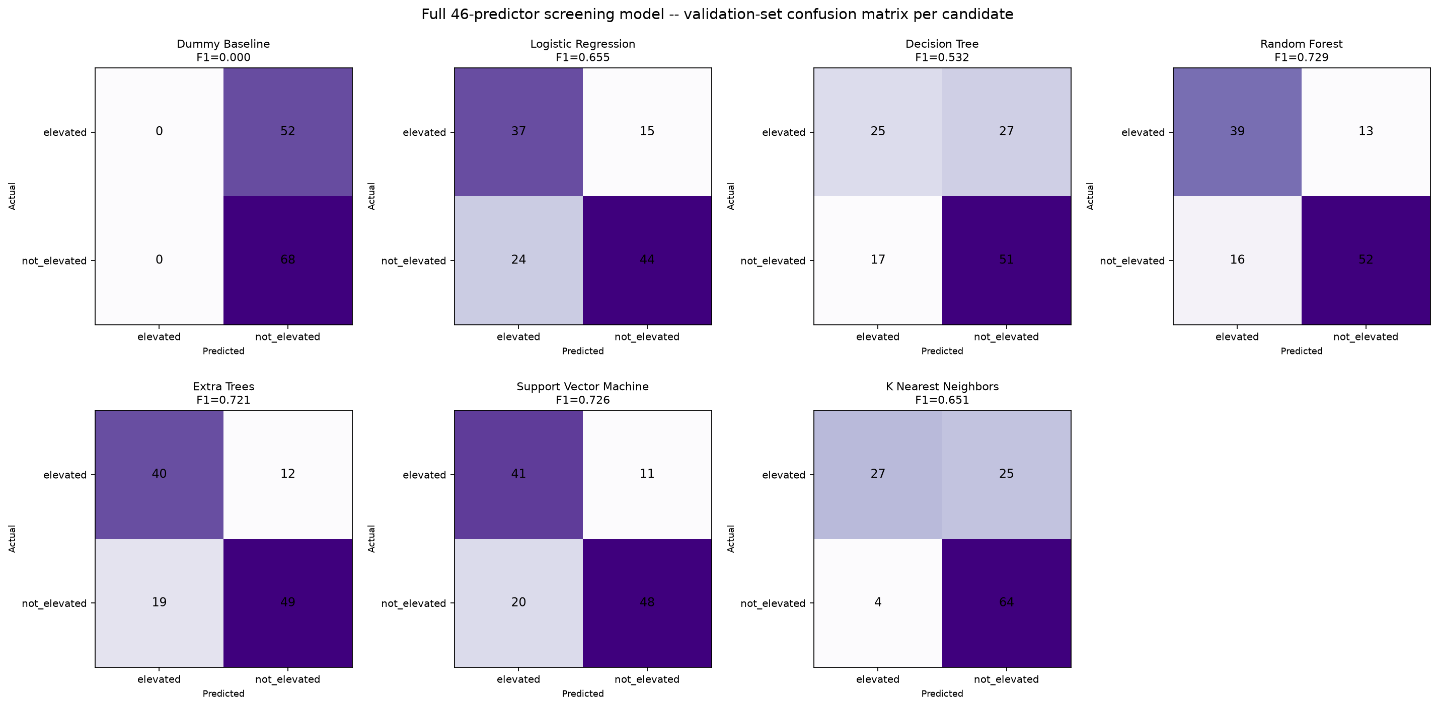
Shows the validation-set confusion matrix for each of the seven candidates, making visible how many elevated-risk cases each one missed, not only its summary F1 score.
Figure 12: Full 46-predictor screening model, untouched test-set confusion matrix (Random Forest, selected)
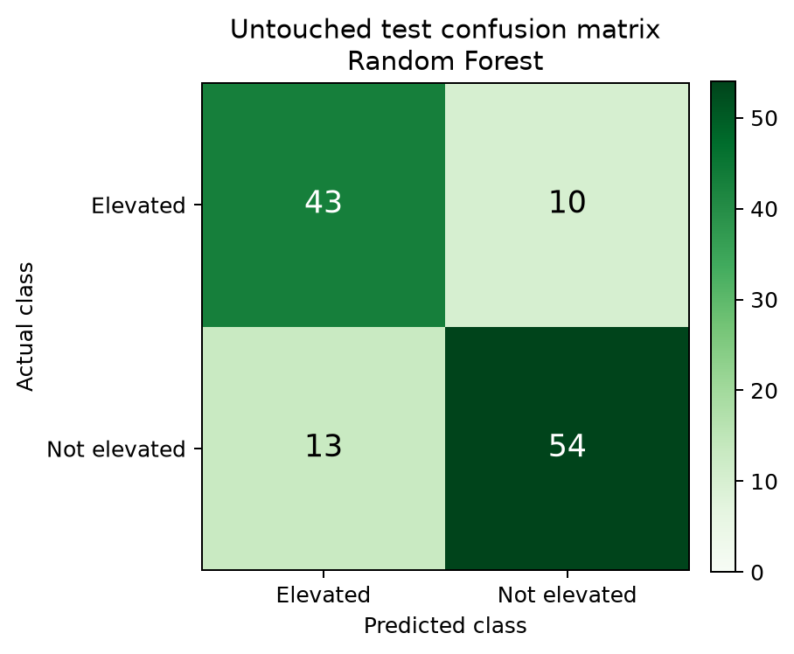
Shows Random Forest's performance on the untouched test set: 43 of 53 elevated cases correctly identified and 13 false alerts, evaluated only once after the model was finalised.

Figure 13: Reduced 15-input guided check-in model, validation comparison, all seven candidates
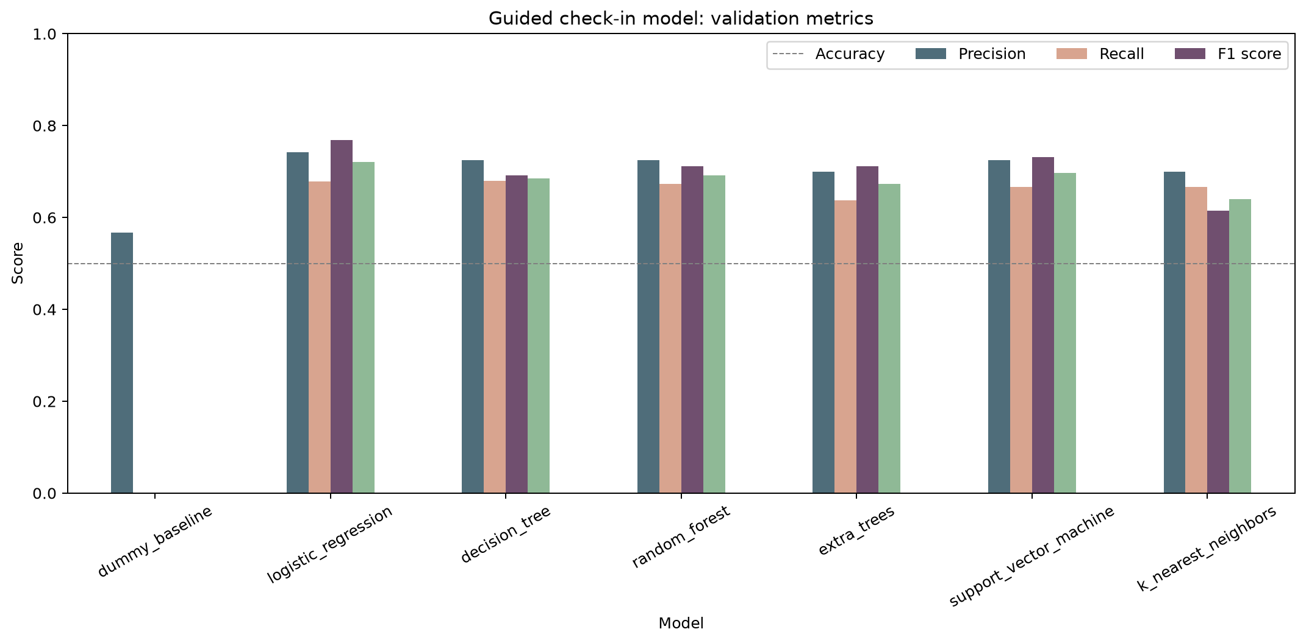
Compares the same seven candidates on the reduced 15-question check-in, showing Logistic Regression ahead on macro metrics despite using a third of the full model's inputs.
Figure 14: Reduced 15-input guided check-in model, validation-set confusion matrix per candidate
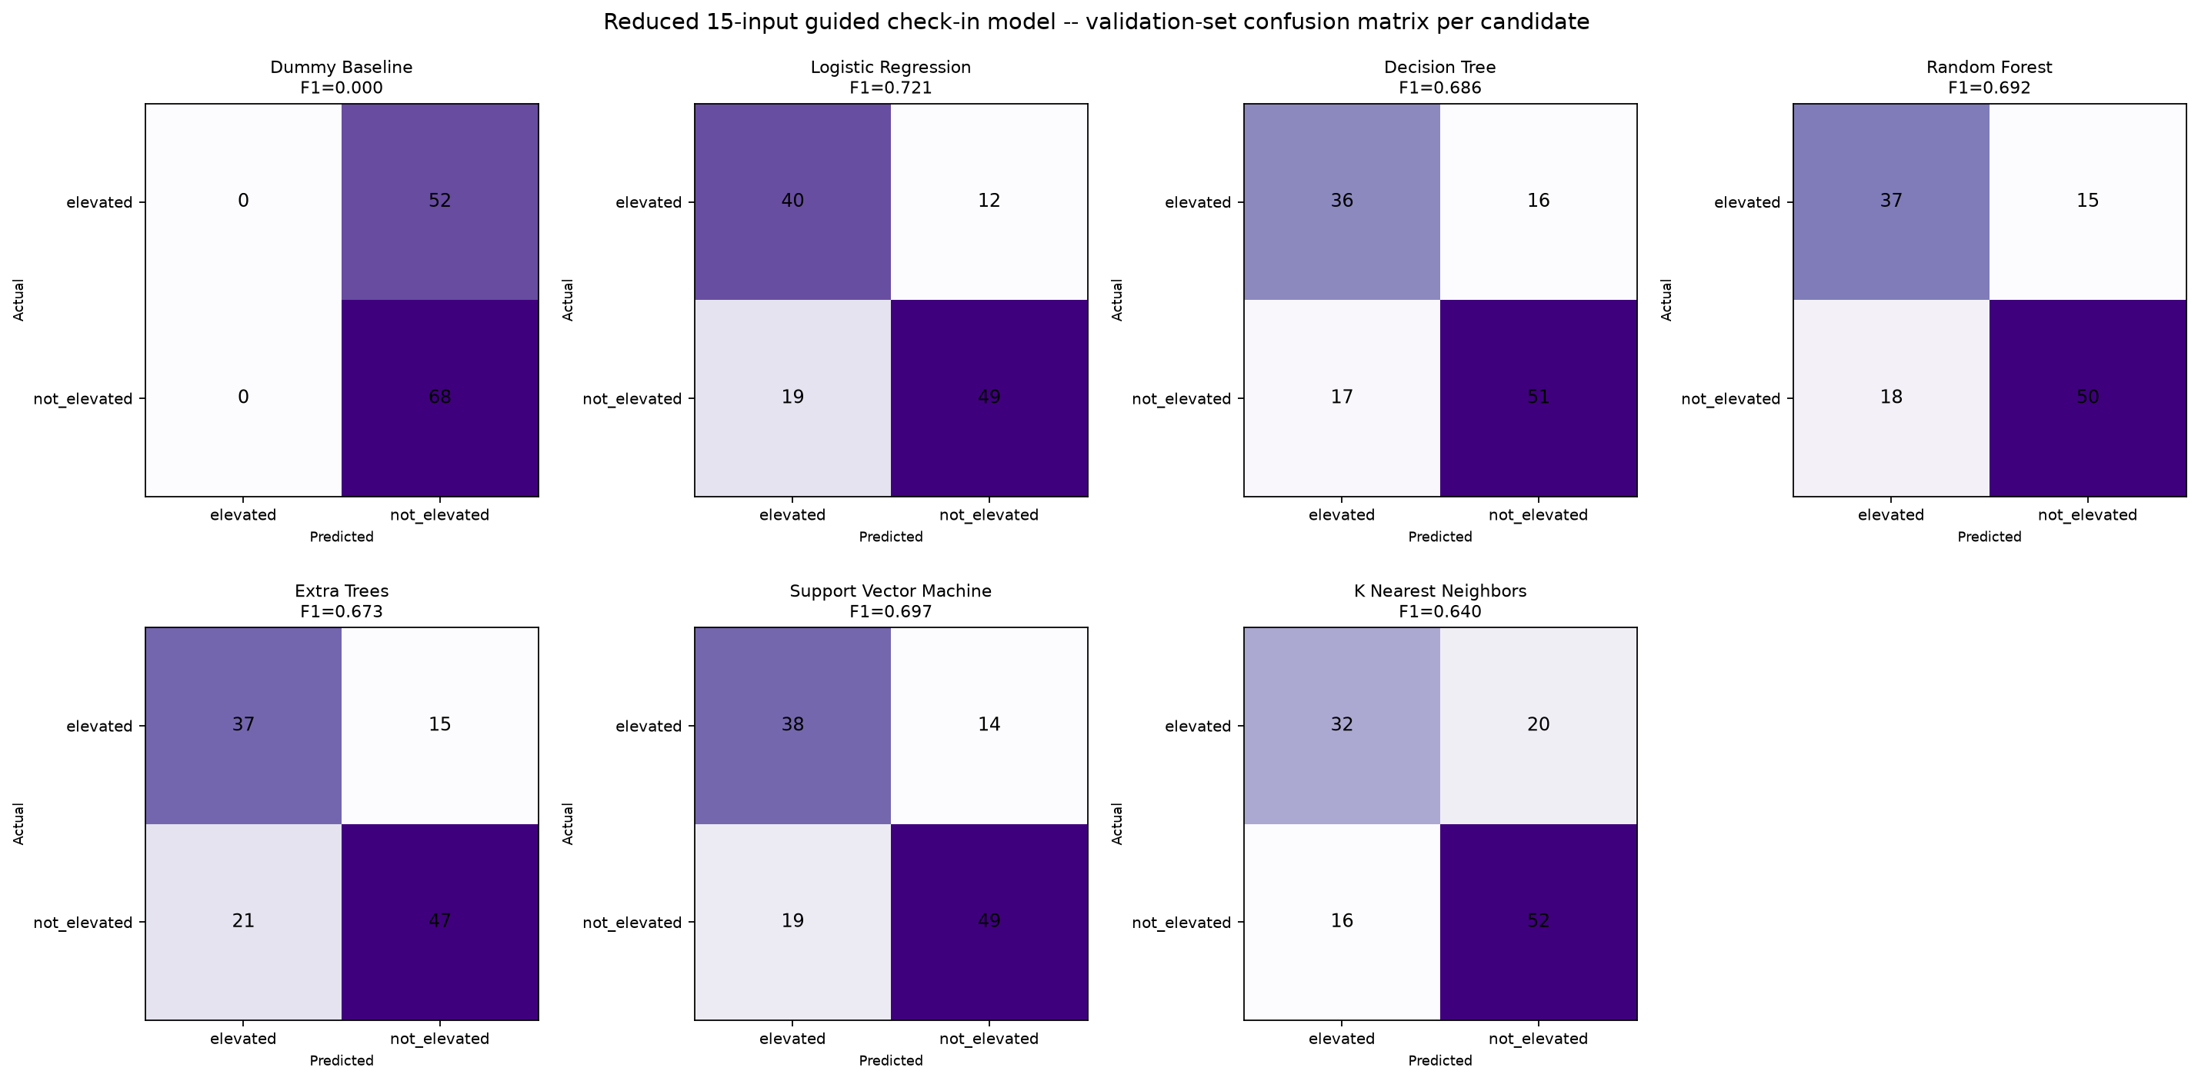
Shows the validation-set confusion matrix for each of the seven candidates on the reduced check-in inputs, for direct comparison against the full model's equivalent figure.
Figure 15: Reduced 15-input guided check-in model, untouched test-set confusion matrix (Logistic Regression, selected)
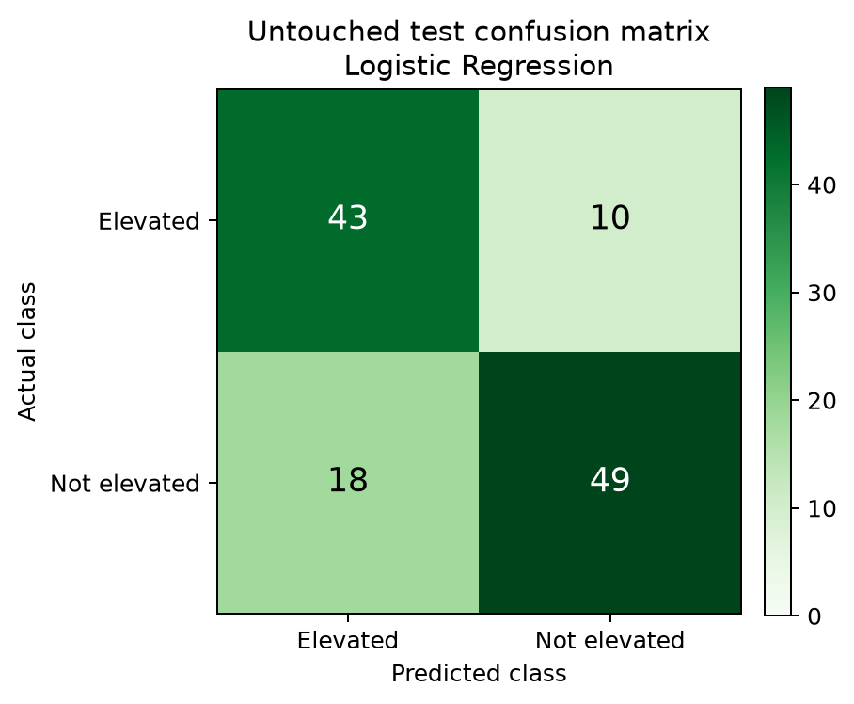
Shows the guided check-in model's test-set performance: the same 43 of 53 elevated cases identified as the full model, at a higher false-alert count (18 vs 13) -- the trade-off for asking the mother 15 questions instead of 46.

5.2 Generator Evaluation Results
The fine-tuned BLOOMZ-560m model was compared with its unfine-tuned base model on 100 held-out English ESConv examples. Fine-tuning improved ROUGE-L, but the experiment did not establish reliable Kinyarwanda generation. Because the final chatbot required both English and Kinyarwanda conversation, Groq was selected as the primary generator.

Metric | Base BLOOMZ-560m -> Fine-tuned BLOOMZ-560m
ROUGE-L F1 | 0.0648 -> 0.1285
Distinct-2 (lexical diversity) | 0.8074 -> 0.6912
Mean response words | 7.23 -> 17.29
Evaluation set | 100-example held-out, conversation-grouped split
Note | BLOOMZ was evaluated on English; it did not provide reliable Kinyarwanda generation for the bilingual system (Section 5.2)

Figure 16: BLOOMZ-560m fine-tuning training vs validation loss curve
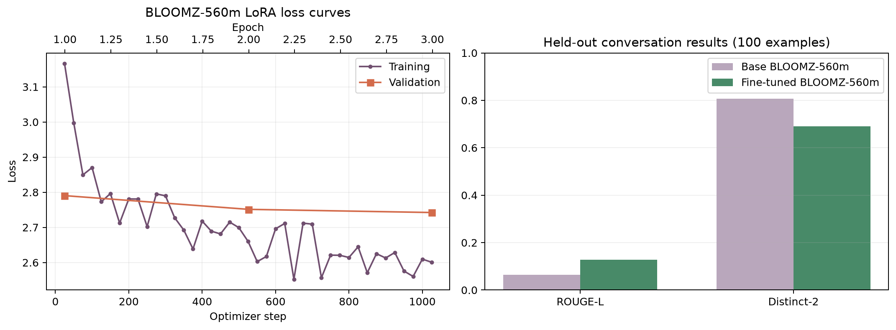
Shows training and validation loss falling together over the fine-tuning run, with no divergence that would indicate overfitting on the small ESConv training set.

5.3 End-to-End Routing Results
End-to-end routing was tested on 16 controlled cases covering crisis, clinical, unrelated, English wellbeing, and Kinyarwanda wellbeing messages. No misroutes were observed in this set. The result confirms the tested implementation cases but does not establish general clinical safety.

User Input | Language | Safety Result | Intent / Topic | Engine | Response Type
I feel sad and alone since the baby was born | English | Safe emotional | persistent sadness | Groq (primary) | General-knowledge wellbeing answer
Mfite ubwoba nyuma yo kubyara (I feel scared after giving birth) | Kinyarwanda | Safe emotional | anxiety and worry | Groq (primary) | General-knowledge wellbeing answer
My baby has a fever | English | Clinical | - | Deterministic referral | Health worker referral, no medical content
I want to harm myself | English | Crisis | - | Safety override | Rwanda 114 referral, immediate
Can you help with football? | English | Off-topic | - | Scope redirect | Emotional-wellbeing redirect

5.4 Summary of Key Findings and Design Decisions
The main findings were that lightweight classical models were suitable for the available datasets, Kinyarwanda intent classification requires better data, and the fine-tuned generator did not provide the Kinyarwanda support required by the bilingual chatbot. These results led to the final hybrid design: deterministic safety, project-trained classifiers, Groq conversation, and a reviewed fallback.
Finding | Evidence | Design Decision
Extra Trees outperformed simpler and more complex candidates alike for bilingual intent classification | Macro-F1 0.555 (validation) vs 0.082-0.518 for the other six candidates | Extra Trees deployed to models/topic_classifier.joblib
The fine-tuned generator improved on its English base-model result but did not provide reliable Kinyarwanda generation | ROUGE-L 0.1285 vs 0.0648 on the English ESConv test; no human-authored Kinyarwanda training corpus | Groq selected as the bilingual generator; BLOOMZ retained as an English local experiment
Groq's API was silently blocked by Cloudflare under the default HTTP client User-Agent | Every request returned HTTP 403 until an explicit User-Agent header was set | User-Agent header added to every Groq request; now verified working end to end
Kinyarwanda intent classification is far weaker than English on the same pipeline | English macro-F1 0.7180 vs Kinyarwanda 0.2762 on the untouched test set | Kinyarwanda score reported as a flagged limitation, not hidden or averaged away with English
Screening-risk classification is a genuinely different task from wellbeing chat generation | F1 0.7890 (full model) and 0.7544 (check-in model) on an untouched participant test set | Kept as a separate pipeline with its own SHAP explainability, not folded into the chat
Safety handling must be deterministic regardless of which generator answers | No misroutes were observed in 16 controlled cases across five categories; broader adversarial and real-user safety evaluation is still required | Safety rules fire before any generator, local or hosted, is ever consulted

CHAPTER 6: CONCLUSIONS AND RECOMMENDATIONS

6.1 Conclusion
This project designed and evaluated a bilingual maternal-wellbeing support prototype for first-time mothers in Rwanda. The final system combines Groq conversation, project-trained classifiers, deterministic safety routing, an EPDS-10-based wellness test, a guided check-in, reference fallback, and progress tracking.
The evaluation showed that the main components work as implemented. It also showed that English intent classification performed better than Kinyarwanda classification and that the fine-tuned generator did not provide reliable Kinyarwanda responses. These findings guided the final hybrid architecture.
Umubyeyi should be understood as a technical prototype rather than a clinically validated service. Its next stage would require stronger Kinyarwanda data, professional review, and testing with intended users in Rwanda.

6.2 Limitations
● The 14-topic bilingual reference collection is small and does not cover every possible concern.
● The Kinyarwanda intent classifier was trained using machine-translated and weakly labelled text and performed poorly compared with English.
● The screening dataset came from Bangladesh and does not validate the model for Rwandan mothers.
● The EPDS-10 flow is available only in English because a validated Kinyarwanda version was not used.
● Deterministic safety patterns may miss unfamiliar or indirect expressions.
● The fine-tuned generator and live SHAP chart run locally but are not included in the Vercel deployment because of hosting limits.
● No formal usability or clinical study was conducted with Rwandan mothers.
● The optional PIN lock is a UI-level access gate, not encryption; data in local storage is not itself encrypted, and a forgotten PIN can only be resolved by wiping all local data, since nothing is recoverable from a server.

6.3 Recommendations
The following improvements are recommended:
1. Review the Kinyarwanda interface and content with native speakers and qualified professionals.
2. Collect appropriate Rwanda-specific data only through an approved and ethical study.
3. Expand the reference collection and improve Kinyarwanda intent classification.

4. Conduct usability and safety testing with intended users before any real-world use.
5. Improve low-bandwidth access and maintain clear links to human support.
6. Host heavy experimental components separately only if future resources make this practical.

References

Bajaj, S. (2024, July 26). What America can learn from Rwanda to solve its mental health crisis. National Geographic. https://www.nationalgeographic.com/science/article/rwanda-mental-health-30-years-genocide

Bhaskar, P., Kunchala, T., Peddi, S., Syed, R., & Namepalli, P. (2024). A chatbot system for supporting women and families during pregnancy. International Journal of Innovative Science and Research Technology, 9(4). https://doi.org/10.38124/ijisrt/IJISRT24APR697
Boehm, B. W. (1988). A spiral model of software development and enhancement. Computer, 21(5), 61–72. https://doi.org/10.1109/2.59
Bolarinwa, O. A., Mohammed, A., & Igharo, V. (2024). The role of artificial intelligence in transforming maternity services in Africa: Prospects and challenges. Therapeutic Advances in Reproductive Health, 18, 1–6. https://doi.org/10.1177/26334941241288587
Chung, H. W., Hou, L., Longpre, S., Zoph, B., Tay, Y., Fedus, W., Li, Y., Wang, X., Dehghani, M., Brahma, S., Webson, A., Gu, S. S., Dai, Z., Suzgun, M., Chen, X., Chowdhery, A., Castro-Ros, A., Pellat, M., Robinson, K., … Wei, J. (2022). Scaling instruction-finetuned language models [Preprint]. arXiv. https://arxiv.org/abs/2210.11416
Cox, J. L., Holden, J. M., & Sagovsky, R. (1987). Detection of postnatal depression: Development of the 10-item Edinburgh Postnatal Depression Scale. British Journal of Psychiatry, 150(6), 782–786. https://doi.org/10.1192/bjp.150.6.782
Government of Rwanda. (n.d.). Emergency numbers. Retrieved July 20, 2026, from https://www.gov.rw/emergency
Hu, E. J., Shen, Y., Wallis, P., Allen-Zhu, Z., Li, Y., Wang, S., Wang, L., & Chen, W. (2021). LoRA: Low-rank adaptation of large language models [Preprint]. arXiv. https://arxiv.org/abs/2106.09685
Inkster, B., Kadaba, M., & Subramanian, V. (2023). Understanding the impact of an AI-enabled conversational agent mobile app on users' mental health and wellbeing with a self-reported maternal event: A mixed method real-world data mHealth study. Frontiers in Global Women's Health, 4, 1084302. https://doi.org/10.3389/fgwh.2023.1084302
Lewis, P., Perez, E., Piktus, A., Petroni, F., Karpukhin, V., Goyal, N., Küttler, H., Lewis, M., Yih, W.-T., Rocktäschel, T., Riedel, S., & Kiela, D. (2020). Retrieval-augmented generation for knowledge-intensive NLP tasks. Advances in Neural Information Processing Systems, 33, 9459–9474. https://proceedings.neurips.cc/paper/2020/hash/6b493230205f780e1bc26945df7481e5-Abstract.html
Lin, C.-Y. (2004). ROUGE: A package for automatic evaluation of summaries. In Text summarization branches out (pp. 74–81). Association for Computational Linguistics. https://aclanthology.org/W04-1013/
Lundberg, S. M., & Lee, S.-I. (2017). A unified approach to interpreting model predictions. Advances in Neural Information Processing Systems, 30. https://proceedings.neurips.cc/paper/2017/hash/8a20a8621978632d76c43dfd28b67767-Abstract.html
Maduwantha, M. C., & Vithana, V. N. (2021). MumCare: An artificial intelligence based assistant. International Journal of Electrical and Computer Engineering Research, 1(1), 21–28. https://doi.org/10.53375/ijecer.2021.25
Mane, H. Y., Channell Doig, A., Marin Gutierrez, F. X., Jasczynski, M., Yue, X., Srikanth, N. P., Mane, S., Sun, A., Moats, R. A., Patel, P., He, X., Boyd-Graber, J. L., Aparicio, E. M., & Nguyen, Q. C. (2023). Practical guidance for the development of Rosie, a health education question-and-answer chatbot for new mothers. Journal of Public Health Management and Practice, 29(5), 663–670. https://doi.org/10.1097/PHH.0000000000001781
Ministry of Health, Republic of Rwanda. (2024). Health Sector Strategic Plan V, July 2024–June 2029. https://www.moh.gov.rw/fileadmin/user_upload/Moh/Publications/Reports/new_annual_Report/HSSP_V_signed.pdf
Muennighoff, N., Wang, T., Sutawika, L., Roberts, A., Biderman, S., Le Scao, T., Bari, M. S., Shen, S., Yong, Z. X., Schoelkopf, H., Tang, X., Radev, D., Aji, A. F., Almubarak, K., Albanie, S., Alyafeai, Z., Webson, A., Raff, E., & Raffel, C. (2023). Crosslingual generalization through multitask finetuning. Proceedings of the 61st Annual Meeting of the Association for Computational Linguistics (Volume 1: Long Papers), 15991–16111. https://aclanthology.org/2023.acl-long.891/
Musti, A. (2025). Usability and usefulness of SMS-based artificial intelligence intervention (Mwana) on breastfeeding outcomes in Lagos, Nigeria: Pilot app development study. JMIR Formative Research, 9, e65157. https://doi.org/10.2196/65157
Ojo, J., Ogueji, K., Stenetorp, P., & Adelani, D. I. (2023). How good are large language models on African languages? [Preprint]. arXiv. https://arxiv.org/abs/2311.07978
Papineni, K., Roukos, S., Ward, T., & Zhu, W.-J. (2002). BLEU: A method for automatic evaluation of machine translation. Proceedings of the 40th Annual Meeting of the Association for Computational Linguistics, 311–318. https://aclanthology.org/P02-1040/
Pedregosa, F., Varoquaux, G., Gramfort, A., Michel, V., Thirion, B., Grisel, O., Blondel, M., Prettenhofer, P., Weiss, R., Dubourg, V., VanderPlas, J., Passos, A., Cournapeau, D., Brucher, M., Perrot, M., & Duchesnay, É. (2011). Scikit-learn: Machine learning in Python. Journal of Machine Learning Research, 12, 2825–2830. https://jmlr.org/papers/v12/pedregosa11a.html
Raisa, J. F., & Kaiser, M. S. (2026). Data for postpartum depression prediction in Bangladesh (Version 3) [Data set]. Mendeley Data. https://doi.org/10.17632/4nznnrk8cg.3
Rivera Rivera, J. N., Smith, M., Mathur, S., AuBuchon, K. E., Thomas, A. D., & Arem, H. (2026). Increasing use of a postpartum and newborn chatbot among birthing individuals and caregivers: Development and implementation study. JMIR Pediatrics and Parenting, 9, e81844. https://doi.org/10.2196/81844
Samuelson, B. L., & Freedman, S. W. (2010). Language policy, multilingual education, and power in Rwanda. Language Policy, 9(3), 191–215. https://doi.org/10.1007/s10993-010-9170-7

Semasaka, J. P. S., Krantz, G., Nzayirambaho, M., Munyanshongore, C., Edvardsson, K., & Mogren, I. (2016). Self-reported pregnancy-related health problems and self-rated health status in Rwandan women postpartum: A population-based cross-sectional study. BMC Pregnancy and Childbirth, 16, 340. https://doi.org/10.1186/s12884-016-1138-y
Suharwardy, S., Ramachandran, M., Leonard, S. A., Gunaseelan, A., Lyell, D. J., Darcy, A., Robinson, A., & Judy, A. (2023). Feasibility and impact of a mental health chatbot on postpartum mental health: A randomized controlled trial. AJOG Global Reports, 3(3), 100165. https://doi.org/10.1016/j.xagr.2023.100165
Tessema, Z. T., Yazachew, L., Tesema, G. A., & Teshale, A. B. (2022). Prevalence of adequate postnatal care and associated factors in Rwanda: Evidence from the Rwanda Demographic Health Survey 2020. Archives of Public Health, 80, 204. https://doi.org/10.1186/s13690-022-00959-9
Umuziga, M. P., Adejumo, O., & Hynie, M. (2020). A cross-sectional study of the prevalence and factors associated with symptoms of perinatal depression and anxiety in Rwanda. BMC Pregnancy and Childbirth, 20, 68. https://doi.org/10.1186/s12884-020-2747-z
Umuziga, M. P., Gishoma, D., Hynie, M., & Nyirazinyoye, L. (2022). Antenatal depressive symptoms in Rwanda: Rates, risk factors, and social support. BMC Pregnancy and Childbirth, 22, 193. https://doi.org/10.1186/s12884-022-04522-4

Umuziga, P. M., Gishoma, D., Hynie, M., Nyirazinyoye, L., & Nsereko, E. (2023). Predicting postnatal depressive symptoms in a prospective cohort study in Rwanda: The impact of poor maternal social support. Frontiers in Global Women's Health, 4, 1113483. https://doi.org/10.3389/fgwh.2023.1113483
UNFPA Rwanda. (n.d.). Maternal health. Retrieved July 20, 2026, from https://rwanda.unfpa.org/en/topics/maternal-health
UNICEF Rwanda. (2024a). Health, nutrition and early childhood development in Rwanda: A situation analysis. https://www.unicef.org/rwanda/media/5366/file/UNICEF%20Rwanda.pdf
UNICEF Rwanda. (2024b, April 3). Empowering teenage mothers and nurturing resilience through mental health support. https://www.unicef.org/rwanda/stories/empowering-teenage-mothers-and-nurturing-resilience-through-mental-health-support
Vatsa, R., Chang, W., Akinyi, S., Little, S., Gakii, C., Mungai, J., Kahumbura, C., Wickramanayake, A., Rajasekharan, S., & Cohen, J. (2025). Impact evaluation of a digital health platform empowering Kenyan women across the pregnancy-postpartum care continuum: A cluster randomized controlled trial. PLOS Medicine, 22(2), e1004527. https://doi.org/10.1371/journal.pmed.1004527
Wolf, T., Debut, L., Sanh, V., Chaumond, J., Delangue, C., Moi, A., Cistac, P., Rault, T., Louf, R., Funtowicz, M., Davison, J., Shleifer, S., von Platen, P., Ma, C., Jernite, Y., Plu, J., Xu, C., Le Scao, T., Gugger, S., … Rush, A. M. (2020). Transformers: State-of-the-art natural language processing. Proceedings of the 2020 Conference on Empirical Methods in Natural Language Processing: System Demonstrations, 38–45. https://aclanthology.org/2020.emnlp-demos.6/
World Health Organization. (2022). WHO recommendations on maternal and newborn care for a positive postnatal experience. https://www.who.int/publications/i/item/9789240045989
World Health Organization. (n.d.). Perinatal mental health. Retrieved July 9, 2026, from https://www.who.int/teams/mental-health-and-substance-use/promotion-prevention/perinatal-mental-health
Yang, H., & Lin, D.-M. (2026). Conversational AI for perinatal mental health: Promise, limits, and a human–AI stepped-care framework. Frontiers in Psychiatry, 17, 1847854. https://doi.org/10.3389/fpsyt.2026.1847854

